Supporting information:

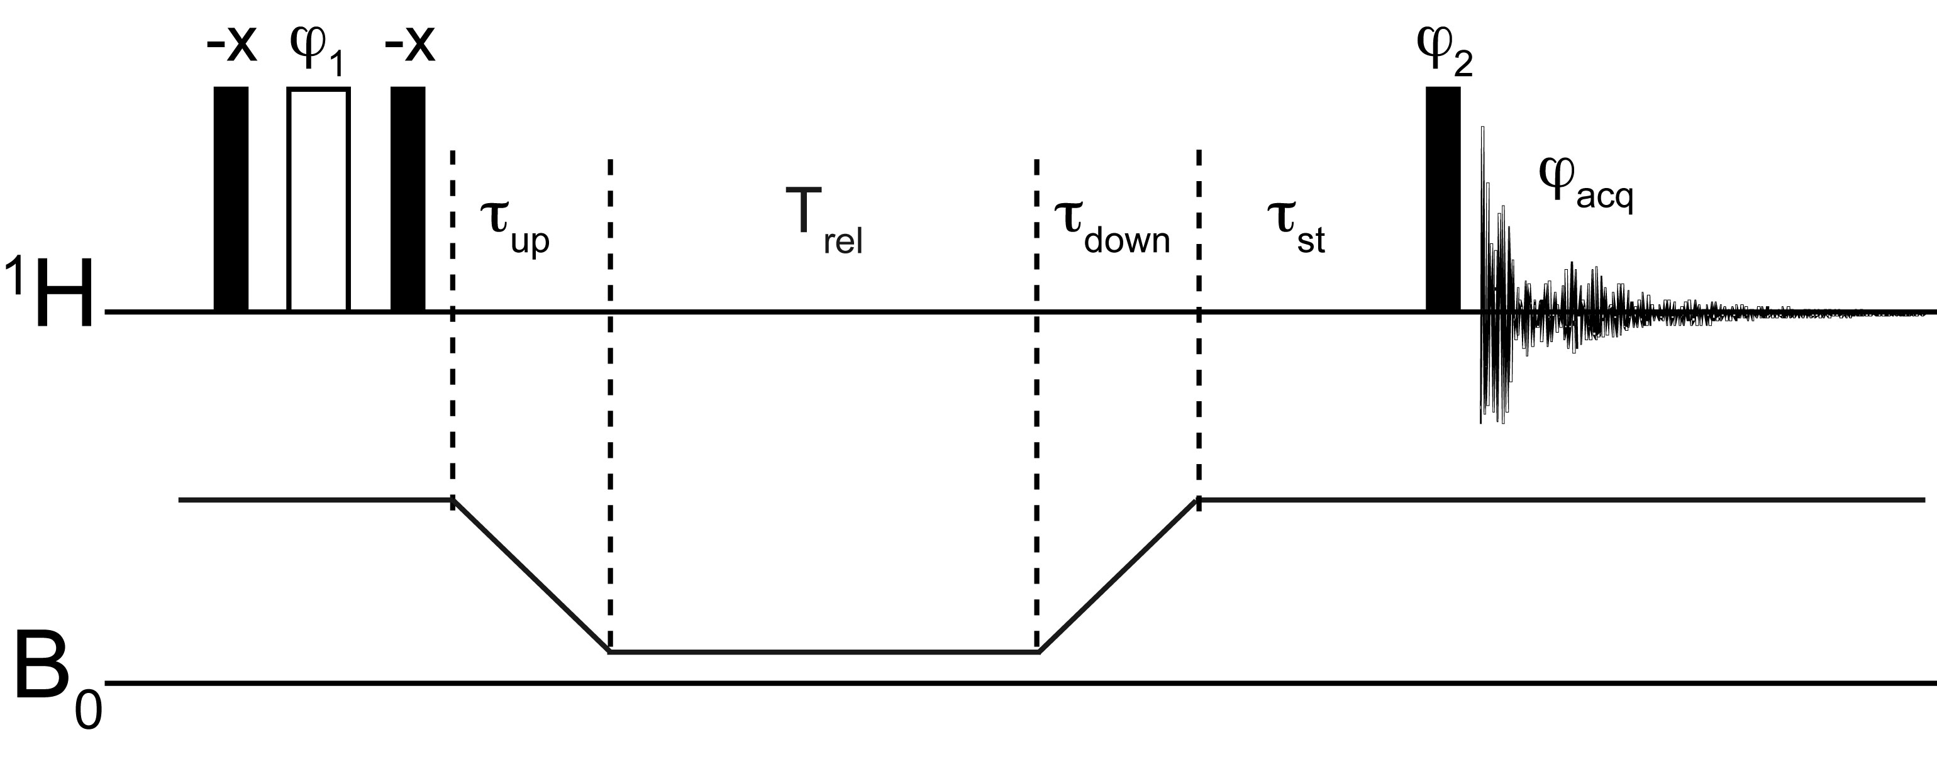
Figure S1: Pulse sequence used for the measurement of low-field longitudinal relaxation of water protons on the sample shuttle apparatus. Narrow filled and wide open rectangles represent 90° and 180° pulses respectively. The recycle delay was 5 s, τ_{up} and τ_{down} were between 60 and 200 ms, depending on the low-field position. The stabilization delay τ_{st} was 250 ms. The phase cycle is ϕ₁ = {x, y}; ϕ₂ = {x, x, -x, -x, y, y, -y, -y}; and ϕ_{acq} = {x, -x, -x, x, y, -y, -y, y}. The inversion of proton polarization every other scan leads to a decay of measured intensities (or integrals) towards zero. The delays T_{rel} were adapted to the relaxation rates at each low field. Ten different delays were chosen and two were repeated. The difference between the minimum and the maximum delays T_{rel} varied between 250 ms and 3.5 s for the USPIO solution and between 0.8 and 1 s for the GadospinTM solution.

