Supplementary Material accompanying
Early degassing of lunar urKREEP by crust-breaching impact(s)
by
Jessica J. Barnes, Romain Tartèse, Mahesh Anand, Francis, M. McCubbin, Clive R. Neal, and Ian A. Franchi

1. Extended Methods
During the first two analytical sessions, secondary ions of ¹⁹F⁻ were not collected due to the very high count rates (being >1 million counts per second), which would have caused significant aging of the EM detector over the duration of a single analysis. During the final analytical session (August 2015), measurement of ¹⁹F on EM#4 was achieved by counting for ~30 s during each analysis using the baseline function of the NanoSIMS, which was enough to obtain a precision comparable to that obtained using electron probe microanalysis (EPMA) (Tartèse et al., 2013; Barnes et al., 2014; Tartèse et al., 2014a).

2. Sample Descriptions
10044, 645
Sample 10044 was collected in the area between the Apollo 11 Lunar Module (LM) and a double elongated crater to the southwest of the LM. Thin-section 10044,645 represents a medium to coarse-grained (grain size up to 2 mm) ophitic ilmenite mare basalt, with high-Ti and low-K contents (Beaty and Albee, 1978). This sample is relatively fresh and is not significantly affected by shock. 10044 is composed of pyroxene, plagioclase, ilmenite, silica, and interstitial areas filled with mesostasis (Beaty and Albee, 1978). This rock has a crystallisation age of ca. 3.72 Ga based on Rb-Sr and Ar-Ar systematics (Albee et al., 1970; Papanastassiou et al., 1970; Guggisberg et al., 1979).
10058,254
Sample 10058 is a high-Ti, low-K type basalt, and belongs to the B1 group of Apollo 11 basalts (Beaty and Albee, 1970). It is a coarse-grained sub-ophitic ilmenite basalt mainly composed of pyroxene, plagioclase, ilmenite and interstitial silica. This rock has an Rb-Sr age of ca. 3.63 ± 0.20 Ga (Albee et al., 1970) and an Ar-Ar age of 3.71 ± 0.04 (Guggisberg et al., 1979).
70035,195
Apollo 17 sample 70035 is a medium-grained, vesicular, high-Ti basalt. It is a large, partially crystalline basalt with large (>1 mm) clinopyroxene crystals, plagioclase, ilmenite, spinel, armalcolite, olivine and mesostasis areas (Weigand, 1973). The Rb-Sr dates of 3.82 ± 0.06 Ga and 3.73 ± 0.11 Ga determined for 70035 are consistent with each other (Nyquist et al., 1977; Evensen et al., 1973) and with an Ar-Ar date of 3.75 ± 0.07 Ga (Stettler et al., 1973).
15555, 206
15555 is a coarse-grained low-Ti olivine-normative basalt composed of olivine, pyroxene (clinopyroxene with pigeonite zonations and Fe-rich rims) and plagioclase with trace amounts of ilmenite and silica (Rhodes et al., 1973). Crystallisation of this rock has been dated by Rb-Sr to be between 3.3-3.54 Ga (Chappell et al., 1972; Murthy et al., 1972; Birck et al., 1975) and 3.32 Ga by Ar-Ar (Podeosek et al., 1972).

14304, 177
14304, 177 is a thin-section of a very high-potassium (VHK) basalt. It is a coarse-grained sample with areas that have been granulated. Mineralogically it is composed of plagioclase, pyroxene (mostly clinopyroxene), olivine, K-feldspar, and K-rich glass (Neal et al., 1989a,b). This sample contains interstitial K-rich areas and vein like structures running through pyroxene, plagioclase, and apatite grains (e.g., Figure 4A). This VHK basalt yielded a Rb-Sr age of 3.95 ± 0.04 Ga and a Sm-Nd age of 4.04 ± 0.11 Ga (Shih et al., 1987). Both ages are within error and the crystallisation age is taken as ~4 Ga.
15386, 46
15386 is the largest sample of pristine KREEP basalt in the Apollo sample collection with a total mass of 7.5 grams. Mineralogically, sample 15386 is composed of plagioclase laths surrounded by interstitial pyroxene. The mesostasis has significant cristobalite (10%), ilmenite, and minor phosphate, iron and sulphide (Meyer et al., 2010). This sample has a crystallisation age of 3912 ± 25 Ma ago (weighted average age calculated by Tartèse et al., 2014a by combining Rb-Sr and Sm-Nd isochron dates from the literature). Note that the studied thin-section is different to the one analysed for apatite D/H-H₂O by Tartèse et al. (2014a).
76535, 51
76535 was collected at the Apollo 17 Station 6 site in the Taurus-Littrow Valley, and is part of a rake sample. It is a remarkably pristine, coarse-grained plutonic rock which has not been altered by shock (Warren and Wasson, 1979). This sample is composed of plagioclase, olivine, orthopyroxene, plus accessory minerals and mesostasis (Gooley et al., 1974; Dymek et al, 1975; Warren, 1993; McCallum and Schwartz, 2001; Elardo et al., 2012). The mesostasis mineral assemblage consists of spinel, clinopyroxene, orthopyroxene, apatite, merrillite, baddeleyite, native Fe-metal, and K-feldspar. 76535 has a crystallisation age of ~ 4.373 ± 0.011 Ga (weighted average age from Papanastassiou and Wasserburg, 1976; Hinthorne et al., 1979; Premo and Tatsumoto, 1992; Nyquist et al., 2012; Carlson et al., 2014).
78235,43
78235 was chipped from a glass covered boulder at Station 8 on the Apollo 17 mission (Jackson et al., 1975). It is classified as a coarse-grained norite (grain size ~ 0.5 mm). This norite is heavily shocked and thin-section 78235,43 contains a sliver of the impact glass that covered the boulder at Station 8. Sample 78235 is mainly composed of orthopyroxene, plagioclase, and trace amounts of clinopyroxene, silica, apatite, merrillite, and glass (e.g., McCallum and Mathez, 1975). Recent age determinations seem to indicate a weighted average crystallisation age of 4.39 ± 0.04 Ga: Nyquist et al., 1982; Edmunson et al., 2009; Andreasen et al., 2013) making 78235 one of the oldest lunar samples in the Apollo collection.
79215, 50
79215 was collected at Station 9 on the Apollo 17 mission. It has been classified as a holocrystalline feldspathic granulitic impactite. 79215 is composed of ~ 72 % matrix and ~ 28 % relict lithic clasts of anorthosite and troctolite rocks (McGee et al., 1978). The matrix portion is composed of plagioclase, olivine, high-Ca pyroxene, low-Ca pyroxene, and minor to trace amounts of oxides, metals and troilite (Bickel et al., 1976; Treiman et al., 2014). The troctolite portion is composed of plagioclase, olivine, orthopyroxene, clinopyroxene, and minor apatite, oxides, spinel and troilite (McGee et al., 1978). Both matrix and a troctolitic clast are present in the studied thin-section, but apatite was only found in the troctolitic portion. This sample has a peak metamorphism age of ca. 3.9 Ga (Oberli et al., 1979; Hudgins et al., 2009).

3. Petrological histories of the lithologies studied
- Magnesian suite (MGS) samples
The MGS group includes the troctolite (76535) and norite (78235) studied in this work. The parent melts to these rocks are considered to have been formed by partial melting of early LMO Mg-rich olivine-dominated cumulates (Shearer et al., 2015) with melting likely initiated by mantle cumulate overturn. The Mg-rich melts are expected to have either assimilated urKREEP en route to the crust or have interacted with urKREEP at the base of the crust, before being intruded into the lunar crust where they experienced slow cooling likely in layered intrusions (reviewed in Shearer et al., 2015). In the case of these samples, the volatile signatures of the primitive melts have been overprinted by the KREEP contamination.
- Metasomatised samples
Whilst troctolite 76535 is a pristine un-shocked sample (Warren, 1993) it is considered to have been affected by post-crystallisation metasomatism (e.g., Elardo et al., 2012). This alteration was likely facilitated by the infiltration of a KREEPy melt that was rich in Cl, Fe and Cr (Elardo et al., 2012). Likewise, granulite 79215 was annealed by impact and is thought to have been subsequently affected by metasomatism, probably of an agent (melt, vapour or fluid) derived from a KREEP component infiltrating the lunar crust that had been mobilised by impact (e.g., Treiman et al., 2014). Thus the volatiles in these samples can be directly related to the varying KREEP component added.
- KREEP-rich basalts
KREEP basalts, inclusive of 15386 which is one of the most KREEP-rich basalts from the Moon, are considered to have formed from the partial melting of primitive olivine and pyroxene cumulates that either already contained an urKREEP component (incorporated during cumulate overturn) or assimilated urKREEP en route to the crust before being erupted onto the lunar surface (Warren and Wasson, 1979).
The very high potassium (VHK) basalts including 14304, are thought to be formed through the assimilation of lunar granite lithologies by a high-aluminium (HA) mare basaltic magma (Shervais et al., 1985; Neal and Taylor, 1989). The variations in texture observed between VHK samples was attributed to different cooling rates within a single lava flow. Recently, Roberts et al. (2014), used textural and petrographic relationships of K-rich glass with host minerals and breccia matrix to invoke an impact origin. They suggested that following breccia formation the breccia was covered in a hot impact melt sheet that melted the low melting point components, such as granite, also present in Apollo 14 breccias, and infiltrated the breccia.
- Mare basalts
The source regions for the mare basalts (e.g., 10044, 10058, 70035, 15555) formed after cumulate overturn. This event is expected to have created the heterogeneous mixture of olivine, pyroxene, and ilmenite cumulates and small degrees of partial melting of these sources created the mare basalts (e.g., reviewed by Grove and Krawczynski, 2009 and Hallis et al., 2014). Limited incorporation of KREEP component is expected in the source regions of the mare basalts, together with varying degrees of ilmenite contamination, and possibly small amounts of trapped instantaneous residual liquid in the mantle cumulates, all would have contributed to the volatile inventory of the source regions for the mare basalts.
4. Electron Probe Microanalysis (EPMA) data
EPMA data collected following the protocol of Barnes et al. (2014) is shown in Supplementary Table 1. Electron microprobe analyses were conducted on apatite in some of the studied samples (10058, 14304, 78235 and 79215) for which data were not available in the literature using the method outlined in Barnes et al. (2014) (Supplementary Table 1).
Supplementary Table 1. Chemical compositions of apatite in samples 10058, 14304, 78235, and 79215. Numbers in parentheses represent the number of analyses. S.d. is the standard deviation of each oxide.
Sample | 10058 (4) |  | s.d. | 14304 (6) | s.d. |  | 78235 (3) | s.d. | 79215 (4) | s.d.
P₂O₅ | 39.85 |  | 1.62 | 42.15 | 0.38 |  | 42.46 | 1.72 | 42.06 | 0.20
SiO₂ | 2.25 |  | 1.58 | 0.30 | 0.04 |  | 0.45 | 0.46 | 0.18 | 0.02
Ce₂O₃ | 0.41 |  | 0.13 | 0.08 | 0.05 |  | 0.02 | 0.01 | 0.01 | 0.02
Y₂O₃ | 1.20 |  | 0.55 | 0.12 | 0.06 |  | 0.01 | 0.02 | 0.07 | 0.01
MgO | 0.03 |  | 0.00 | 0.35 | 0.07 |  | 0.11 | 0.02 | 0.18 | 0.01
CaO | 52.38 |  | 1.32 | 55.49 | 0.25 |  | 54.50 | 0.97 | 56.05 | 0.41
MnO | 0.02 |  | 0.01 | 0.01 | 0.01 |  | 0.00 | 0.01 | 0.00 | 0.01
FeO | 0.68 |  | 0.19 | 0.36 | 0.07 |  | 0.26 | 0.19 | 0.22 | 0.07
Na₂O | 0.01 |  | 0.02 | 0.01 | 0.01 |  | 0.00 | 0.00 | 0.00 | 0.00
SO₂ | 0.09 |  | 0.17 | 0.01 | 0.01 |  | 0.07 | 0.04 | 0.03 | 0.02
F | 3.46 |  | 0.29 | 3.65 | 0.24 |  | 3.14 | 0.53 | 3.94 | 0.11
Cl | 0.06 |  | 0.03 | 0.44 | 0.11 |  | 0.78 | 0.06 | 0.66 | 0.02
F=O | 1.46 |  |  | 1.54 |  |  | 1.32 |  | 1.66
Cl=O | 0.01 |  |  | 0.10 |  |  | 0.18 |  | 0.15
Total | 98.96 |  |  | 101.34 |  |  | 100.29 |  | 101.60
 |  | Stoichiometry based on 13 anions
P | 2.87 |  |  | 2.97 |  |  | 3.00 |  | 2.96
Si | 0.19 |  |  | 0.03 |  |  | 0.04 |  | 0.02
Ce | 0.01 |  |  | 0.00 |  |  | 0.00 |  | 0.00
Y | 0.05 |  |  | 0.01 |  |  | 0.00 |  | 0.00
Mg | 0.00 |  |  | 0.04 |  |  | 0.01 |  | 0.02
Ca | 4.78 |  |  | 4.95 |  |  | 4.88 |  | 5.01
Mn | 0.00 |  |  | 0.00 |  |  | 0.00 |  | 0.00
Fe | 0.05 |  |  | 0.02 |  |  | 0.02 |  | 0.02
Na | 0.00 |  |  | 0.00 |  |  | 0.00 |  | 0.00
S | 0.01 |  |  | 0.00 |  |  | 0.01 |  | 0.00
F | 0.93 |  |  | 0.96 |  |  | 0.83 |  | 1.04
Cl | 0.01 |  |  | 0.06 |  |  | 0.11 |  | 0.09
OH | 0.06 |  |  | 0.00 |  |  | 0.06 |  | 0.00
Sum | 7.96 |  |  | 8.02 |  |  | 7.95 |  | 8.03
P site | 3.06 |  |  | 2.99 |  |  | 3.04 |  | 2.98
Ca site | 4.90 |  |  | 5.03 |  |  | 4.91 |  | 5.05

For the other samples, apatite compositions are given by Tartèse et al. (2013) for 10044 and 15555, Tartèse et al. (2014a) for 15386, McCubbin et al. (2011), Elardo et al. (2012) and Barnes et al. (2014) for 76535, and Treiman et al. (2014) for 79215. EMPA data has not yet been collected for apatite in 70035. Stoichiometry was calculated on the basis of thirteen anions (see McCubbin et al., 2011 for a discussion of the various stoichiometric normalisation methods specific to apatite). The analytical reproducibility of fluorine values on apatite standards was better than 0.3 wt.%, except for analysis of apatite in 79215, which all exhibited anomalously high F contents. All other analyses resulted in satisfactory stoichiometric totals. As already recognised in previous studies, one of the main characteristics of lunar apatite is their F-rich nature (McCubbin et al., 2011; Tartèse et al., 2013; McCubbin et al., 2015). In all the studied samples excluding mare basalt 15555, all of the apatite crystals have >3 wt.% fluorine, corresponding to > ~80 mol.% F in the apatite volatile site.

5. Relating the heavy Cl-isotopic composition of lunar apatite to a KREEP component
Supplementary Table 2 provides the data and literature references used to assess whether variable KREEP contamination might be responsible for the unique Cl-isotopic compositions of lunar samples (Figure 8).

Supplementary Table 2. Bulk-rock La and Sm concentrations and bulk-rock ε¹⁴³Nd initial values of the samples studied in this work and 12039* and 12040* (studied by Boyce et al., 2015).
Sample | La (ppm) | Reference(s) | Sm (ppm) | Reference(s) | ε¹⁴³ Nd initial | Reference(s)
10044 | 10.22 ± 1.23† | Wänke et al., 1970  Wakita et al., 1970  Kharkar et al, 1971  Rhodes and Blanchard, 1980  Neal 2001 | 17.73 ± 3.95† | Wänke et al., 1970  Wakita et al., 1970  Kharkar et al, 1971  Philpotts and Schnetzler,1970 | +7.10 ± 0.4 | Snyder et al., 1994
10058 | 10.2 ± 0.20 | Hallis et al., 2014 | 15.6 ± 0.30 | Hallis et al., 2014 | +7.6 ± 0.4 | Snyder et al., 1994
15555 | 1.79 ± 0.03 | Hallis et al., 2014 | 1.34 ± 0.02 | Hallis et al., 2014 | +2.80 ± 0.3† | McCleod et al., 2014  Sprung et al., 2013  Rankenburg et al., 2006  Brandon et al., 2009
70035 | 7.97 ± 0.12 | Hallis et al., 2014 | 12.6 ± 0.20 | Hallis et al., 2014 | +6.60 ± 1.6 | Sprung et al., 2013
14304 | 25.2 ± 0.30 | Neal et al., 1989b | 12.1 ± 0.20 | Neal et al., 1989b | +0.27 ± 0.3 | Shih et al., 1987
15386 | 78.3 ± 1.20 | Hallis et al., 2014 | 34.1 ± 0.6 | Hallis et al., 2014 | -1.98 ± 0.5† | McCleod et al., 2014  Rankenburg et al., 2006  Brandon et al., 2009
76535 | 1.51 | Haskin et al., 1974 | 0.61 | Haskin et al., 1974 | -0.64 ± 0.5† | Borg et al., 2014  Premo and Tatsumoto, 1992
78235 | 4.47 | Blanchard and McKay, 1981 | 1.93 | Blanchard and McKay, 1981 | -0.27 ± 0.7 | Edmunson et al., 2009 ‡
79215 | 3.23 ± 0.21† | Hudgins et al., 2008 | 1.46 ± 0.19† | Hudgins et al., 2008 | - | -
12039* | 7.25 | Nyquist et al., 1977 | 4.8 | Nyquist et al., 1977 | +5.00 ± 0.3 | Sprung et al., 2013
12040* | 4.04 ± 0.06 | Hallis et al., 2014 | 3.18 ± 0.06 | Hallis et al., 2014 | +3.78 | McCleod et al., 2014
Where: ‡ data is for sample 78238. † indicate averages and standard deviations of multiple analyses, all other uncertainties represent the respective analytical uncertainties where available.

6. Additional methods accompanying the modelling calculations

We have applied a Rayleigh distillation model to calculate the degree of Cl isotope fractionation caused by degassing of metal chlorides. In this model the fractionation factor α is related to the mass difference between the two isotopologue species constituting of the vapour phase (e.g., Zn³⁵Cl₂ and Zn³⁷Cl₂) and is given by α = √(m₁/m₂), where m₁ and m₂ are the masses of the light and heavy isotopologues, respectively. This gives α values of 0.987 for NaCl, 0.989 for ZnCl₂ and 0.988 for FeCl₂. Using these α values, we calculated that >85% volatilisation of Cl as NaCl, or >90 % volatilisation of Cl as either FeCl₂ or ZnCl₂, would increase the δ³⁷Cl value of Cl remaining in the melt to ~+30 ‰, starting from an Earth-like initial δ³⁷Cl of 0 ‰.
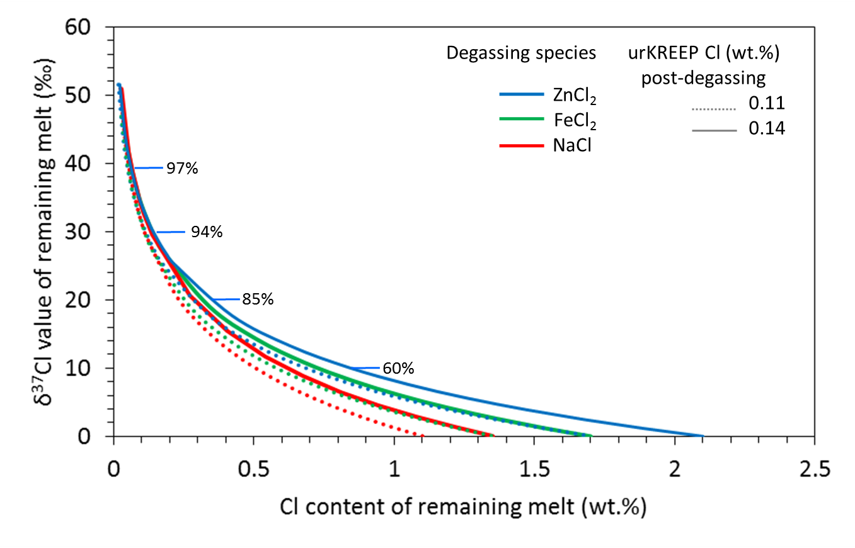
Supplementary Figure 1. Degassing curves for the loss of various metal chlorides from urKREEP. The model uses the different α values for the various metal chloride species (details in the text) and the various post-degassing Cl contents estimated for urKREEP (reviewed in McCubbin et al., 2015a). The % of degassing are relevant to the loss of ZnCl₂.
Estimates for the Cl content of urKREEP (~1350 ppm, McCubbin et al., 2015) indicate that the un-degassed urKREEP magmatic liquid would have contained ~2 wt. % Cl (Supplementary Figure 1)
In the main manuscript, scenarios involving the contemporaneous degassing of H, either as H₂ or HCl, are considered. Supplementary Figure 2 details these degassing models. The curves use the fractionation factors of Richet et al. (1999) calculated for temperatures in the range of 900 to 1300 °C. Two starting H-isotopic compositions are assumed A) -400 ‰ (representing the lowest measured δD value from a KREEP-rich lunar sample; Barnes et al., 2014) and B) -200 ‰, representing approximately the average δD value for water in KREEP-rich lithologies.
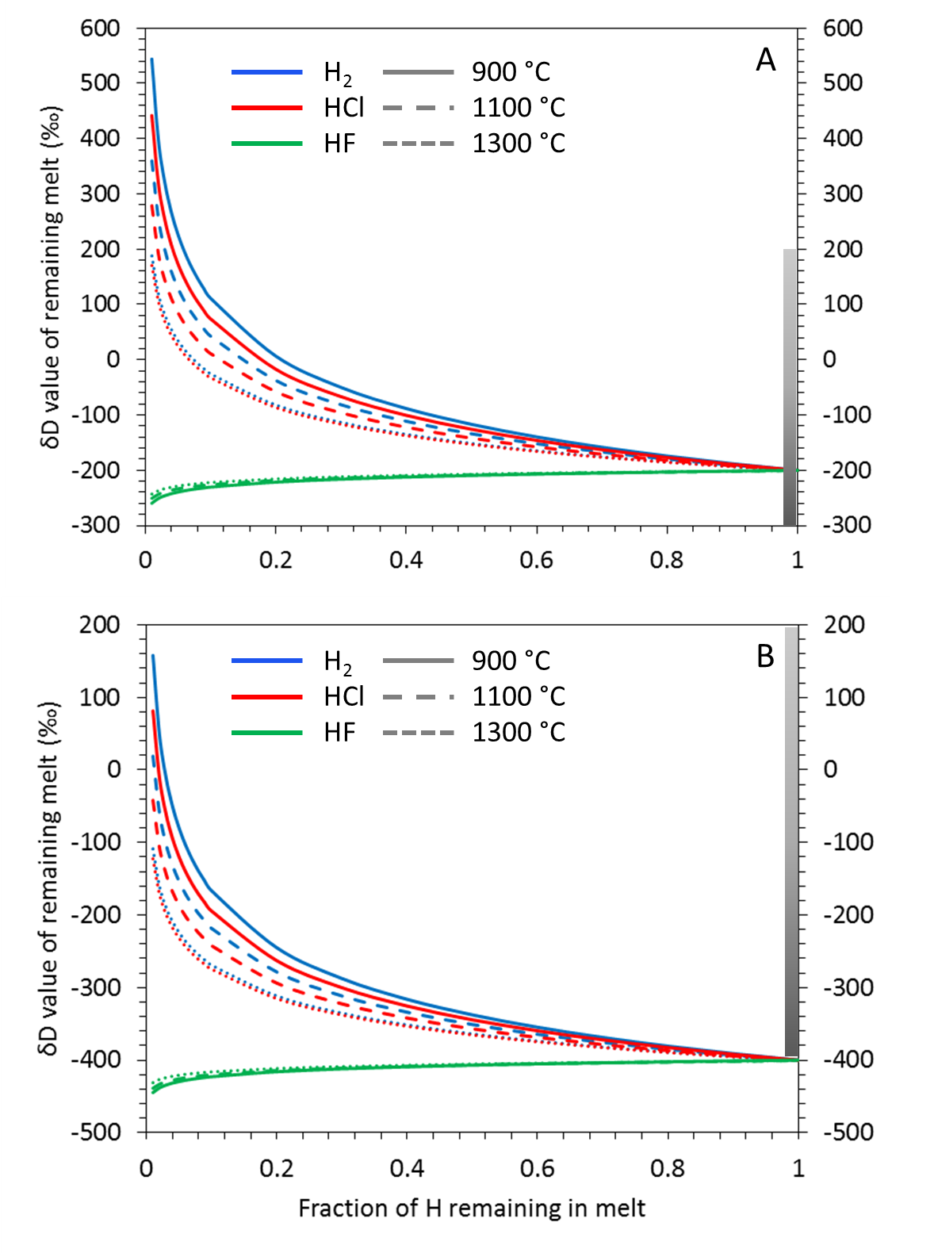
Supplementary Figure 2. Hydrogen degassing models for loss of H from urKREEP, assuming an un-degassed H-isotopic composition for urKREEP of A) -400 ‰ and B) -200 ‰, and assuming H is lost as H₂, HCl, or HF. The grey bars indicate the current range of H-isotopic compositions measured in KREEP-rich lithologies (Barnes et al., 2014; Tartèse et al., 2014).

In some scenarios, as outlined in the main manuscript, there may be a requirement for post-accretion addition of volatiles to the Moon. For the addition of chondritic material to the Moon, a LMO depth of 400 km and a density of 3300 kg m⁻³ were assumed after Barnes et al. (2015). Using constraints from Day et al. (2007), Barnes et al. (2015) calculated that a maximum amount of 52 ppm water could have been delivered to the Moon during the lifetime of the LMO, which equates to the addition of 1.46×10¹⁹ kg of CI-type carbonaceous chondrite material (assuming the bulk water contents for carbonaceous chondrites from Alexander et al. (2012)). Note that the addition of water by carbonaceous chondrites during and particularly after the event that degassed urKREEP, means that water in urKREEP should be characterised by the same H-isotopic composition (between -200 and +200 ‰) as water found in the carbonaceous chondrites (Alexander et al., 2012). Assuming that the bulk chlorine content of CI-type carbonaceous chondrites is 0.1 wt.%, associated with a δ³⁷Cl value of ~0 ± 1 ‰ (Sharp et al., 2013), then the maximum Cl that is added to the lunar interior during late accretion is 1.46×10¹⁶ kg Cl. If the BSM Cl value is assumed to be of the lower estimate ~3.94×10¹⁸ kg (~100 ppm, McCubbin et al., 2015) then late accretion adds <0.5 % of the total BSM Cl abundance. Therefore, the maximum amount of Cl added during late accretion is insignificant, and will result in negligible change in the post-degassing Cl isotopic composition of urKREEP by <0.15 ‰, which is within current analytical uncertainty.

Additional references
Albee, A. L. et al. Ages, irradiation history, and chemical composition of lunar rocks from the Sea of Tranquillity. Science 167, 463-466 (1970).
Andreasen, R., Simmons, S. T., Righter, M. & Lapen, T. J. Lutetium-hafnium and Samarium-Neodymium systematics of Apollo 17 sample 78235: Age and the importance of thermal neutron fluence on the Lutetium-Hafnium system. 44th Lunar Planet. Sci. Conf. 2887 (2013).
Barnes, J. J. et al. Determining the source(s) of water in the lunar interior. 46th Lunar Planet. Sci. Conf., abstract #2159 (2015). Beaty, D. W. & Albee, A. L. Comparative petrology and possible genetic relations among the Apollo 11 basalts. 9th Lunar Planet. Sci. Conf. 359–463 (1978).
Bickel, C. E., Warner, J. L. & Phinney, W. C. Petrology of 79215-Brecciation of a lunar cumulate. 7th Lunar Sci. Conf. 1793–1819 (1976).
Birck, J. L., Fourcade, S. & Allegre, C. J. ⁸⁷Rb-⁸⁶Sr age of rocks from the Apollo 15 landing site and significance of internal isochrons. Earth Planet. Sci. Lett. 26, 29-35 (1975)
Blanchard, D. P. & McKay, G. A. Remnants from the ancient lunar crust III: Norite 78236. 12th Lunar Planet. Sci. Conf. 83–85 (1981).
Borg, L. et al. Evidence for widespread magmatic activity at 4.36 Ga in the lunar highlands from young ages determined on troctolite 76535. 44th Lunar Planet. Sci. Conf. 1563 (2014).
Brandon, A. D. et al. Re-evaluating 142Nd/144Nd in lunar mare basalts with implications for the early evolution and bulk Sm/Nd of the Moon. Geochim. Cosmochim. Acta 73, 6421–6445 (2009).
Carlson, R. W., Borg, L. E., Gaffney, A. M. & Boyet, M. Rb-Sr , Sm-Nd and Lu-Hf isotope systematics of the lunar Mg-suite: the age of the lunar crust and its relation to the time of Moon formation. Philos. Trans. R. Soc. A Math. Phys. Eng. Sci. 372, 1–21 (2014).
Chappell, B. W., Compston, W., Green, D. H. & Ware, N.G. Chemistry, geochronology, and petrogenesis of lunar sample 15555. Science 175, 415-416 (1972).
Dymek, R. F., Albee, A. L. & Chodos, A. A. Comparative petrology of lunar cumulate rocks of possible primary origin: Dunite 72415, troctolite 76535, norite 78235, and anorthosite 62237. 6th Lunar Sci. Conf. 301–341 (1975).

Edmunson, J., Borg, L. E., Nyquist, L. E. & Asmerom, Y. A combined Sm-Nd, Rb-Sr, and U-Pb isotopic study of Mg-suite norite 78238: Further evidence for early differentiation of the Moon. Geochim. Cosmochim. Acta 73, 514–527 (2009).
Elardo, S. M., McCubbin, F. M. & Shearer, C. K. Chromite symplectites in Mg-suite troctolite 76535 as evidence for infiltration metasomatism of a lunar layered intrusion. Geochim. Cosmochim. Acta 87, 154–177 (2012).
Evensen, N. M., Murthy, V. R. & Coscio, M. R. Rb-Sr ages of some mare basalts and the isotopic and trace element systematics in lunar fines. 4th Lunar Sci. Conf. 1707-1724 (1973).
Gooley, R., Brett, R., Warner, J. & Smyth, J. R. A lunar rock of deep crustal origin: sample 76535. Geochim. Cosmochim. Acta 38, 1329–1339 (1974).
Grove, T. L. & Krawczynski, M. J. Lunar mare volcanism: Where did the magmas come from? Elements 5, 29–34 (2009).
Guggisberg, S. et al. Classification of the Apollo-11 mare basalts according to Ar39-Ar40 ages and petrological properties. 10th Lunar Planet. Sci. Conf. 1–39 (1979).
Hallis, L. J., Anand, M. & Strekopytov, S. Trace-element modelling of mare basalt parental melts: Implications for a heterogeneous lunar mantle. Geochim. Cosmochim. Acta 134, 289–316 (2014).
Haskin, L. A. et al. Chemical evidence for the origin of 76535 as a cumulate. 5th Lunar Sci. Conf. Supp. 5, Geochim. Cosmochim. Acta 1213–1225 (1974).
Hudgins, J. A., Spray, J. G., Kelley, S. P., Korotev, R. L. & Sherlock, S. C. A laser probe 40Ar/39Ar and INAA investigation of four Apollo granulitic breccias. Geochim. Cosmochim. Acta 72, 5781–5798 (2008).
Hinthorne, J. R., Andersen, C. A., Conrad, R. L. & Lovering, J. F. Single-grain 207Pb206Pb and U/Pb age determinations with a 10-μm spatial resolution using the ion microprobe mass analyzer (IMMA). Chem. Geol. 25, 271–303 (1979).
Jackson, E. D., Sutton, R. L. & Wilshire, H. G. Structure and petrology of a cumulus norite boulder sampled by Apollo 17 in Taurus-Littrow Valley, the Moon. Bull. Geol. Soc. Am. 86, 433–442 (1975).
Kharkar, D. P. & Turekian, K. K. Analyses of Apollo 11 and Apollo 12 rocks and soils by neutron activation. 2nd Lunar Sci. Conf. 1301–1305 (1971).
McCallum, I. S. & Mathez, E. A. Petrology of noritic cumulates and a partial melting model for the genesis of Fra Mauro basalts. 6th Lunar Sci. Conf. 395–414 (1975).
McCallum, I. S. & Schwartz, J. M. Lunar Mg suite: Thermobarometry and petrogenesis of parental magmas. J. Geophys. Res. 106, 27969–27583 (2001).
McGee, J. J., Bence, A. E. & Schaeffer, O. A. Conditions of metamorphism and age. 9th Lunar Planet. Sci. Conf. 1354 (1978).
McGee, J. J., Bence, A. E., Eichhorn, G. & Schaeffer, O. A. Feldspathic granulite 79215-Limitations on T-fO2 conditions and time of metamorphism. 9th Lunar Planet. Sci. Conf. 743–772 (1978).
McLeod, C. L., Brandon, A. D. & Armytage, R. M. G. Constraints on the formation age and evolution of the Moon from ¹⁴²Nd-¹⁴³Nd systematics of Apollo 12 basalts. Earth Planet. Sci. Lett. 396, 179–189 (2014).
Meyer, C. Lunar Sample Compendium. (2010).
Murthy, R., Evensen, N. M., Jahn, B-M. & Coscio, M. R. Jr. Apollo 14 and 15 samples: Rb-Sr ages, trace elements, and lunar evolution. Proc. 3rd, Lunar Sci. Conf. 1503-1514 (1972).
Neal, C. R. Interior of the moon: The presence of garnet in the primitive deep lunar mantle. J. Geophys. Res. 106, 27865-27885 (2001).
Neal, C. R. & Taylor, L. A. Metasomatic products of the lunar magma ocean: The role of KREEP dissemination. Geochim. Cosmochim. Acta 53, 529–541 (1989).
Neal, C. R., Taylor, L. A. & Patchen, A. D. High Alumina (HA) and very high potassium (VHK) basalt clasts from Apollo 14 breccias, Part 1 – Mineralogy and petrology: Evidence of crystallisation from evolving magmas. 19th Lunar Planet. Sci. Conf. 137-145 (1989a).
Neal, C. R., Taylor, L. A., Schmitt, R. A., Hughes, S. S. & Lindstrom, M. M. High alumina (HA) and very high potassium (VHK) basalt clasts from Apollo 14 breccias. II-Whole rock geochemistry-Further evidence for combined assimilation and fractional crystallization within the lunar crust. 19th Lunar Planet. Sci. Conf., 147-161 (1989b).
Nyquist, L. E., Shih, C.-Y. & Reese, Y. D. Redetermination of the Sm-Nd age and initial eNd of lunar troctolite 76535: Implications for lunar crustal development. 43rd Lunar Planet Sci. Conf. 2416 (2012).
Nyquist, L. E. et al. A comparative Rb-Sr, Sm-Nd, and K-Ar study of shocked norite 78236 - Evidence of slow cooling in the lunar crust. 12th Lunar Planet. Sci. Conf. 67–97 (1982).
Nyquist, L. E. Lunar Rb-Sr chronology. Physics Chem. Earth 10, 103-142 (1977).
Nyquist, L. E., Bansal, B. M., Wooden, J. L. & Wiesemeyer, H. Sr-isotopic constraints on the petrogenesis of Apollo 12 mare basalts. 8th Lunar Sci. Conf. 1383–1415 (1977).
Oberli, F., Huneke, J. C. & Wasserburg, G. J. U-Pb and K-Ar systematics of cataclysm and precataclysm lunar impactites. 10th Lunar Planet. Sci. Conf. 940–942 (1979).
Papanastassiou, D. A. & Wasserburg, G. J. Rb-Sr age of troctolite 76535. 7th Lunar Sci. Conf. 2035–2054 (1976).
Papanastassiou, D. A., Wasserburg, G. J. & Burnett, D. S. Rb-Sr ages of lunar rocks from the Sea of Tranquility. Earth Planet. Sci. Lett. 8, 1–19 (1970).
Philpotts, J. A. & Schnetzler, C. C. Apollo 11 lunar samples: K, Rb, Sr, Ba and rare-earth concentrations in some rocks and separated phases. Apollo 11 Lunar Sci. Conf. 1471–1486 (1970).
Podosek, F. A., Huneke, J. C. & Wasserburg, G. J. Gas retention and cosmic ray exposure ages of lunar rock 15555. Science 175, 423-425 (1972).
Premo, W. R. & Tatsumoto, M. U-Th-Pb, Rb-Sr, and Sm-Nd isotopic systematics of lunar troctolitic cumulate 76535-Implications on the age and origin of this early lunar, deep-seated cumulate. 22nd Lunar Planet. Sci. Conf. 381–397 (1992).
Rankenburg, K., Brandon, A. D. & Neal, C. R. Neodymium isotope evidence for a chondritic composition of the Moon. Science 312, 1369–1372 (2006).
Rhodes, J. M. & Blanchard, D. P. Chemistry of Apollo 11 low-K mare basalts. 11th Lunar Planet. Sci. Conf. 49–66 (1980).
Rhodes, J. M. & Hubbard, N. J. Chemistry, Classification, and Petrogenesis of Apollo 15 mare basalts. 4th Lunar Sci. Conf. Suppl. 4, Geochim. Cosmochim. Acta 2, 1127–1148 (1973).
Roberts, S. E. & Neal, C. R. Taking off the potassium coat: A new hypothesis for VHK petrogenesis. 45th Lunar Planet. Sci. Conf. 1282 (2014).
Shervais, J. W., Taylor, L. A., Laul, J. C., Shih, C.-Y. & Nyquist, L. E. Very high potassium (VHK) basalt: Complications in mare basalt petrogenesis. 16th Lunar Planet. Sci. Conf. Part 1 J. Geophys. Res. D3–D18 (1985).
Shih, C.-Y. et al. Geochronology of high-K aluminous mare basalt clasts from Apollo 14 breccia 14304. Geochim. Cosmochim. Acta 51, 3255–3271 (1987).
Snyder, G. A., Lee, D-C., Taylor, L. A., Halliday, A. N. & Jerde, E. A. Evolution of the upper mantle of the Earth’s Moon: Neodymium and strontium isotopic constraints from high-Ti basalts. Geochim. Cosmochim. Acta 58, 4795-4808 (1994).
Sprung, P., Kleine, T. & Scherer, E. E. Isotopic evidence for chondritic Lu/Hf and Sm/Nd of the Moon. Earth Planet. Sci. Lett. 380, 77–87 (2013).
Stettler, A., Eberhardt, P., Geiss, J., Grogler, N. & Maurer, P. Ar39-Ar40 ages and Ar37-Ar38 exposure ages of lunar rocks. 4th Lunar Sci. Conf. 1865-1888 (1973).
Wakita, H., Schmitt, R. A. & Rey, P. Elemental abundances of major, minor and trace elements in Apollo 11 lunar rocks, soil and core samples. Apollo 11 Lunar Sci. Conf. 1685–1717 (1970).
Wänke, H. et al. Major and trace elements in lunar material. Apollo 11 Lunar Sci. Conf. 1719–1727 (1970).
Warren, P. H. A concise compilation of petrologic information on possibly pristine nonmare Moon rocks. Am. Mineral. 78, 360–376 (1993).
Warren, P. H. & Wasson, J. T. Pristine nonmare rocks and the nature of the lunar crust. 8th Lunar Planet. Sci. Conf. 2215–2235 (1977).
Weigand, P. W. Petrology of a coarse-grained Apollo 17 ilmenite basalt. EOS. 54, 621-622 (1973).

