Title: New species of Iodes fruits (Icacinaceae) from the early Eocene Le Quesnoy locality, Oise, France.
Cédric Del Rio^{1, 2, *}, Gregory W. Stull³, Dario De Franceschi¹

¹ CR2P - Centre de Recherche en Paléontologie - Paris, MNHN - Sorbonne Université - CNRS, CP38, 57 rue Cuvier, 75231 Paris Cedex 05, France

² ISYEB - Institut de Systématique, Évolution, Biodiversité, CNRS, MNHN, Sorbonne-Université, EPHE, CP39, 57 rue Cuvier, 75231 Paris Cedex 05, France
³ Department of Ecology and Evolutionary Biology, University of Michigan, Ann Arbor, Michigan, 48109, USA

*Author for correspondence, cedric.del-rio@edu.mnhn.fr
Abstract: The floristic diversity of the Le Quesnoy amber locality (Ypresian, Oise France) remains understudied. Icacinaceae Miers, particularly, require careful study, as they are the most abundant family in the site, with 185 nearly complete lignitic endocarps specimens and numerous fragments. In this paper, we recognise three species of Icacinaceae, two of which are new, that belong to the genus Iodes. Indeed, all Iodes species from this site have the following diagnostic characters: a vascular bundle inside the endocarp wall, a reticulum of external ridges, and papillae on the surface of the locule. Iodes rigida sp. nov differs from the others in having a hole at the apex, a pattern of reticulation that delimits some areoles, an “I-Beam” ridge structure, and punctuated and heterogeneous sessile, rounded papillae. Iodes acuta sp. nov. is distinct from the others due to its unique apical outgrowth (composed of the main ridge that runs from the base up to the apex and a protuberance from the keel merged), a very thin wall, and sharp ridges. Therefore, these new species have a combination of new morpho-anatomical characters never observed before and not found in extant Iodes species. Despite some scarce differences, some specimens from Le Quesnoy are attributed to I. parva. Finally, several seeds are recognized as Icacinaceae without particular affinity. These seeds are elliptical in shape, lenticular in transverse section, and slightly asymmetrical to completely asymmetrical at the apex. A review of the Iodes fossil record is provided. The significance of endocarp ridge morphology is discussed in light of new fossils and extant data. These fossils show affinities with representatives from other Eocene sites of Europe and with the Thanetian Rivecourt site (Oise, France) and appear to have mixed affinities with the modern floras of Asia and Africa. Other studies on this remarkable site, focusing on additional taxonomic groups, are necessary to elucidate the relationship between Le Quesnoy and other floras from the past and the present.

Key Words: endocarp, fossil, Iodes, new species, seed.
- Introduction
Icacinaceae are a family of trees, shrubs, and climbers with a pantropical distribution (De La Bâthie, 1952; Sleumer, 1971; Villiers, 1973). Traditionally, the family contained about 54 genera and 400 species (Sleumer, 1942). However, the lack of clear synapomorphies led to confusions around the taxonomy and phylogeny of this group. Recent phylogenetic studies using morphological and molecular data have greatly clarified the phylogeny of Icacinaceae, allowing recognition of a monophyletic—and much reduced—circumscription of 23 genera and about 150 species (Kårehed, 2001; Lens et al., 2008, Byng et al., 2014; Stull et al., 2015). This clade, along with the family Oncothecaceae, is now placed in the order Icacinales (APG, 2016), which is sister to all other lamiids (Stull et al., 2015). The Icacinaceae s.s. are well known in the fossil record in Paleogene localities from Europe, such as the London Clay flora (Reid and Chandler, 1933; Chandler, 1961a, 1961b, 1962; Collinson, 1983; Cleal et al., 2001; Stull et al., 2016), the Messel biota (Collinson et al., 2012), and the Dormaal Formation (Fairon-Demaret and Smith, 2002). Remains from the Paleogene of North America are also well documented (Crane et al., 1990, Manchester, 1994; Manchester, 1999, Pigg and Wher, 2002, Pigg et al., 2008, Rankin et al., 2008, Stull et al., 2011, Stull et al., 2012, Allen et al., 2015). In addition, several fossils of the family are known from South America (Stull et al., 2012) and Egypt (Manchester and Tiffney, 1993); additional material has been reported from Africa (Chandler, 1954, Chester, 1955) and Japan (Tanai, 1990), but the affinities of these fossils are more dubious.
The fossil record of the family is dominated by endocarps, which tend to be taxonomically informative (Stull et al., 2016). Multiple clades of Icacinaceae are diagnosable by fruit characters—for example, the genus Iodes Blume is characterized by elliptical to globular endocarps, lenticular in transverse section, with an external reticular pattern, a papillate layer on the inner surface (locule), and a vascular bundle running from the base to the apex embedded in the endocarp wall. Iodes, which contains ~23 extant species, is the most abundantly represented genus of Icacinaceae in the fossil record.
These endocarp features are present in numerous fossils from the Le Quesnoy site, suggesting the presence of Iodes at this Paleogene locality. The faunal and floral diversity of the Le Quesnoy amber locality (Ypresian, Oise, France) was first studied by Nel et al. (1999). Particular elements of the flora have been examined; for example, there are studies focused on flowers and pollen grains preserved in amber (De Franceschi et al., 2000, De Franceschi and De Ploëg, 2003; Del Rio et al., 2017), lignitic fossil fruits and seeds (Nel et al., 1999), and Menispermaceae endocarps (Jacques and De Franceschi, 2005). However, the diversity of the flora remains understudied. In this paper, we describe two new species of Iodes based on fossil endocarps and document a new occurrence of a species that was already described recently from the Rivecourt site (Del Rio et al., 2018); in addition to the endocarp remains, we also document multiple seeds specimens attributed to Icacinaceae, without specific affinity. We discuss the morphological variation of modern and fossil Iodes endocarps, establishing a context for assessing the systematic affinities of the new species.

2. Material and methods

2.1 Material
The lignitic fossil specimens were collected from Le Quesnoy locality (Houdancourt, Oise, France) from 1996 to 2000, from the lignitic clay sediments of Le Quesnoy outcrop, representing the lower Eocene. The sediments indicate that this site corresponds to an ancient fluvial depositional environment (for location and geological setting, see De Franceschi and De Ploëg, 2003; Smith et al., 2014). Based upon the mammalian fauna (e.g. Teilhardina, Landenodon sp., Paschatherium sp. and Palaeonictis cf. gigantea; Nel et al., 1999), these sediments are dated at MP7 (Lower Ypresian, ~56 Ma), with corroboration from palynological studies (Nel et al., 1999; Cavagnetto, 2000). This corresponds to the Sparnacian facies of the Lower Ypresian (Lower Eocene).
Approximately 185 nearly complete endocarps of Icacinaceae were collected, primarily representing lignified samples, but some pyritized specimens were also obtained. In addition, some lignitic fragments assigned to Icacinaceae were also collected. The fossils are kept in the palaeobotanical collections of the Muséum national d’Histoire naturelle (MNHN) at Paris, collection De Franceschi - De Ploëg. Endocarps of living species of Iodes were sampled from herbarium specimens (Tab.1), obtained from the Muséum national d’Histoire naturelle de Paris (P), the Royal Botanic Garden Kew (K), the Botanic Garden Meise (BR) and the Missouri Botanical Garden (MO). We sampled 14 of the 23 extant species of Iodes, spanning the biogeographic breadth of the genus, providing us a relatively comprehensive picture of its morphological diversity. Voucher information is available in appendix.

2.2 Method of collection
The fruits were extracted and sieved from the lignitic clay sediments. They were slowly dried after being treated with diluted hydrogen peroxide and washed in water and then they were kept in dry conditions. Once dried, the different sediment fractions were sorted using a binocular microscope (Mantis Elite). The pyritized samples are stored with a dehydration agent (silica gel).

2.3 Method of observation
All specimens were studied with a binocular microscope (Wild M3Z) and imaged with a Leica DFC 420 camera. Measurements were taken using the ImageJ Software (Rasband 2016). Cell diameters and papillae were measured 10 times for each species, using random selections of the specimens. Multiple samples were coated with gold-palladium for examination by Scanning Electron Microscopy (SEM), using a Jeol JCM6000 instrument, facilitating observation of anatomical features, especially the endocarp wall layers and papillae.

- Systematics
The general fruit features of Icacinaceae are present in the species described here: bilateral endocarps, usually elliptical, with an asymmetrical apex and containing a single-seeded. The fossils show additional features generally associated with the Iodeae tribe (which is now understood to by polyphyletic; see Stull et al., 2015): the presence of a keel surrounding the endocarp, the pattern of ridges at the surface (which delimitate areoles), and papillae on the inner endocarp surface. However, these features, combined with a vascular bundle inside the endocarp wall and notably round papillae, suggest affinities with Iodes, which can be distinguished from other genera of Icacinaceae based on this unique combination of characters. Additionally, more subtle characters permit the recognition of three species, two of which are newly described here.

Order- Icacinales Tiegh.
Family- Icacinaceae Miers
Genus- Iodes Blume
Species- Iodes rigida Del Rio and De Franceschi sp. nov.
Fig.1, 1-12

Diagnosis. Endocarp bilaterally symmetrical, elliptical to ovate, occasionally globular, with a reticulate pattern of rectangular (I-Beam) ridges that delimit about 11 polygonal areoles on each face, with few or no freely ending ridgelets. A keel surrounds the endocarp in the plane of symmetry, with the thicker margin containing a vascular bundle embedded in the endocarp wall. Endocarp possessing an apical hole. Endocarp wall about 0.26–0.50 mm thick (excluding ridges; 0.43–0.58 mm including ridges). Inner endocarp surface densely covered with regularly spaced, sessile papillae, rounded in shape with small punctuations/depressions on the surface. Length of endocarp 3.72–9.29 mm, width 3.01–6.54mm.

Etymology. From rigidus (L = rigid), in reference to the strong ridges of the endocarp structure.

Holotype. MNHN.F. 44593.
Stratigraphy. Early Eocene.

Type locality. Le Quesnoy (Oise, France).

Paratypes. MNHN.F.44547., 44548., 44555., 44557., 44558., 44560., 44561., 44563., 44564., 44565., 44566., 44567., 44568., 44570., 44572., 44573., 44575., 44577., 44578., 44579., 44580., 44581., 44582., 44583., 44584., 44585., 44586., 44587., 44588., 44589., 44590., 44591., 44592., 44594., 44595., 44596., 44597., 44598., 44599., 44600., 44601., 44602., 44603., 44604., 44606., 44607., 44608., 44609., 44610., 44611., 44612., 44613., 44615., 44616., 44617., 44618., 44619., 44620., 44621., 44622., 44623., 44624., 44625., 44626., 44627., 44629., 44630., 44631., 44632., 44633., 44635., 44637., 44640., 44641., 44642., 44645., 44646., 44647., 44649., 44650., 44651., 44653., 44654., 44655., 44656., 44657., 44658., 44659., 44661., 44662., 44663., 44665., 44666., 44667., 44670., 44672., 44673., 44674., 44675., 44678., 44679., 44680., 44681., 44683., 44684., 44685., 44686., 44688., 44689., 44690., 44691., 44692., 44693., 44695., 44697., 44698., 44699., 44703., 44711., 44712., 44713., 44714., 44716., 44717.

Description. Endocarp bilaterally symmetrical, unilocular, single-seeded, elliptical to ovate (Fig.1, 1–6), occasionally globular, lenticular in transverse section; length, 3.72–9.29 (avg. 6.25 mm; SD= 0.89, n=115), width 3.01–6.54 (avg. 4.79 mm; SD=0.73, n=110). Outer part of endocarp with reticulate pattern of “I-Beam” ridges, a particular shape of rectangular ridges with a channel on the median apical part of the surface corresponding to the trace left by the outer vasculature at the boundary between endocarp and mesocarp (Fig.1, 7), occasionally preserved. Each endocarp face generally includes five longitudinal ridges (Fig.1, 1–6); Ridges without connexions or delimiting up to 20 polygonal areoles on each lateral face, avg. 11, with few or no freely ending ridgelets. A keel surrounds the endocarp in the plane of symmetry (Fig.1, 2) with the thicker margin containing a vascular bundle embedded in the endocarp wall (Fig.1, 10). Endocarp possessing an apical hole (Fig.1, 4). Endocarp wall 0.26–0.50 mm thick (avg. 0.38 mm; SD=0.1, n=4) excluding ridges, 0.43–0.58 mm thick (avg. 0.51 mm; SD=0.06, n=9) including ridges; see Fig.1, 8). Wall composed of packed, interlocking digitate and sclerotic cells in a layer with about four units of cell rows; the outermost unit consists of numerous apical cell rows, difficult to distinguish; the second unit corresponds to a single row of isodiametrical cells, 0.039–0.104 mm in diameter; the basal sclerotic unit is composed of numerous rows of periclinal cells, 0.019-0.050 mm in length. Inner endocarp surface is densely covered with regularly spaced, sessile papillae, rounded in shape with small punctuations on the surface (Fig.1, 11–12); the papillae correspond to the cell expansions of the locule epidermal layer; papillae diameter 0.010–0.026 mm (MNHN.F.44601., 44607., 44666., 44667., 44698., 44703.); the number of papillae per 0.25 mm² is between 290 and 570 (MNHN.F.44601., 44666., 44667., 44698., 44703.).

Remarks. This is the most abundant species at the Le Quesnoy site, with 125 endocarps and a few fragments. The single row of isodiametric cells is a fragile zone (Fig.1, 8). Almost all broken specimen show a ridge section with this layer; papillae are very heterogeneous in form ranging from small to elongate to relatively large (Fig.1, 10 & 11). The pattern of ridges is generally consistent across all specimens (Fig.2), but we show the extreme forms of this species in Fig.2. The ridge pattern is composed first of one ridge, on the medial part of each face, which begins at the base (or almost the base) and runs up two thirds of the length of the endocarp (Fig.2). Two series of ridges (noted 2 & 2’ and 3 & 3’ on Fig.2) running along each side complete the longitudinal ridges, with the secondary ones (2 & 2') well developed and the third ones (3 & 3') more or less developed. The occurrence of all ridges depends on the global shape of the endocarp. Punctuations in the papillae could correspond to an exchange zone between endocarp and seed.

Systematic affinity. This species differs from others in having a hole at the apex (Fig.1, 4), a pattern of reticulation that delimits some areoles (Fig.1, 1, 3 & 6), the “I-Beam” ridge structure (Fig.1, 8), and the punctuated and heterogeneous sessile, rounded papillae (Fig.1, 12). Despite overlap in size, this species differs from I. acuta by having rectangular ridges and endocarp walls twice as thick. It differs from I. parva in lacking horn-like protrusions and possessing distinctive rectangular ridges. Iodes rigida differs from I. bilinica, I. eocenica, I. acutiformis, I. brownii, I. corniculata and all the other species from Rivecourt site (Del Rio et al., 2018) in having no horn-like protrusions but rather an apical hole. In addition, this species differs from I. bilinica in size and in having no free-ending ridges; from I. eocenica in having a clearly smaller size (3.7–9.3 mm vs 13.5–15 mm, Tab.1); from I. acutiformis in lacking an acute apex and having rectangular, rather than sharp, ridges; from I. brownii by its different pattern of ridges and distinct endocarp wall shape (?) and from I. corniculata in having rectangular ridges. It differs from I. occidentalis (Allen et al., 2015) in having no free-ending ridges, fewer areoles, and rectangular ridges. This species seems to be close to I. multireticulata Reid and Chandler from the London Clay (Reid and Chandler, 1933) sharing the apical hole and a pattern of reticulation without free-ending ridges (Stull et al., 2016). However, specimens from Le Quesnoy are generally smaller in size, with a length of 3.7–9.3 mm compared to 8.0–12.5 mm for I. multireticulata. In addition, I. rigida has a maximum of 20 areoles per endocarp face, which is less than I. multireticulata (30–50 areoles per face). The most important distinction is the shape of the ridges: the rectangular ridges of I. ridiga do not correspond to those described and illustrated for I. multireticulata (Reid and Chandler, 1933). Finally, the papillae diameter of I. multireticulata is more greater than that of I. rigida (50 vs max 26 μm), but this last difference could be due to taphonomic bias. I. germanica seems to be close to these new species but is typically smaller and shows more areoles and less vertical ridges (Knobloch and Mai, 1986). However, the lack of detail provided for the papillae and ridge characters in the original description of I. germanica makes difficult a thorough comparison. The length of Paleohosiea suleticensis species (here considered as potential Iodes species, see general discussion) is considerably greater than I. rigida (15–20 mm vs 3.7–9.3 mm). Finally, Paleohosiea marchiaca seems to be very close in shape and size but has low, rounded ridges, which are distinct from the ridges of I. rigida.

Species - Iodes acuta Del Rio and De Franceschi sp. nov.
Fig.1, 13-24
Diagnosis. Endocarp bilaterally symmetrical, unilocular, single-seeded, elliptical to ovate, with a reticulate pattern of sharp and sinuous ridges, which delimit about 17 polygonal areoles on each face with few or no freely ending ridgelets. A keel surrounds the endocarp in the plane of symmetry with the thicker margin containing a vascular bundle embedded in the endocarp wall. Endocarp possessing an apical outgrowth composed of the main ridge that runs from the base up to the apex and a protuberance from the keel merged. Endocarp wall about 0.08–0.19 mm thick excluding ridges (0.18–0.39 mm including ridges). Inner endocarp surface densely covered with regularly spaced more or less punctuated and sessile rounded papillae. Length of endocarp about 5.8–8.0 mm, width about 3.61–5.42 mm.
Etymology. From acutus (L=sharpened, made sharp) in reference of the shape of ridges.
Holotype. MNHN.F.44571.

Stratigraphy. Early Eocene.

Type locality. Le Quesnoy (Oise, France).

Paratypes. MNHN.F.44551., 44553., 44554., 44576., 44605., 44614., 44634., 44668., 44682., 44687., 44696., 44700., 44701., 44704., 44705., 44718., 44719.

Description. Endocarp bilaterally symmetrical, unilocular, single-seeded, elliptical to ovate (Fig.1, 14–18), lenticular in transverse section; length 5.8–8.0 (avg. 6.91 mm; SD= 0.79, n=12), width 3.61–5.42 (avg. 4.76 mm; SD=0.63, n=13). Outer part of endocarp with a reticulate pattern of sharp and sinuous ridges (Fig.1, 19). Each face of the endocarp with 3–6 longitudinal ridges, which delimit 10–25 polygonal areoles on each lateral face, avg. 17, with few or no freely ending ridgelets. A keel surrounds the endocarp in the plane of symmetry (Fig.1, 14), with the thicker margin containing a vascular bundle embedded in the endocarp wall (Fig.1, 22). Endocarp possessing an apical outgrowth (Fig.1, 16) composed of the main ridge that runs from the base up to the apex and a protuberance from the keel merged; Endocarp wall 0.08–0.19 mm thick (avg. 0.13 mm; SD=0.04, n=3) excluding ridges; 0.18–0.39 mm thick (avg. 0.29 mm; SD=0.08, n=4) including ridges. Wall composed of packed interlocking digitate and sclerotic cells with four units of unicellular and multicellular cell rows (Fig.1, 20–21); the outermost unit corresponds to an apical sclerotic layer of numerous cell rows, difficult to distinguish; the second unit corresponds to one row of isodiametric-oriented cells, 0.035–0.041 mm in diameter; the basal sclerotic unit is composed of numerous rows of periclinal cells. Inner endocarp surface densely covered with regularly spaced, more or less punctuated, sessile papillae, rounded in shape (Fig.1, 23–24), which correspond to the cell expansions of the locule epiderma layer; papillae diameter 0.010–0.018 mm (MNHN.F.44554., 44668., 44705., 44718.); the number of papillae per 0.25 mm² is between 230 and 410 (MNHN.F. 44554., 44668.).

Remarks. This species is represented by 18 lignitic fossils from Le Quesnoy. Two morphotypes are remarkable, one elongate (Fig.1, 18) and one more elliptical with a thicker and more delicate keel (Fig.1, 13-17). Despite these conspicuous features, the anatomical data allow consideration of these two shapes as an intraspecific variation, showing the great plasticity of this species. The wall is exceptionally thin for an icacinaceous endocarp. We show numerous mycelium filaments between papillae (Fig.1, 23-24). These filaments have the same lignitic nature of endocarp, indicating that the mycelium represents a probable saprophytic consumption before fossilisation.

Systematic affinity. This new species is distinct from the others due to its unique apical outgrowth, composed of the main ridge that runs from the base up to the apex and a protuberance from the keel merged (Fig.1, 16), a very thin wall (Fig.1, 20-21), and sharp ridges (Fig.1, 19). It differs from I. rigida and I parva by its sharper ridges. Iodes acuta shares this shape of ridges with I. acutiformis, I.bilinica, I.sinuosa and I. tubulifera, all species from European Eocene sites; other species have clearly rounded or rectangular ridges (Tab. 1). I. acutiformis has a thicker endocarp wall (200 μm vs max. 130 μm) and an acute apex, which is not found in I. acuta. In addition, the papillae seem to be denser in I. acutiformis, but we do not have information about the shape and diameter of the papillae for comparison. I. acuta differs from I. bilinica (Collinson et al., 2012) in overall size (5.8–8.0 mm vs 9.0–16.0 mm length), the absence of free-ending ridges, and endocarp thickness (for I. bilinica, 650 μm, Tab.1). I. germanica is smaller than I. acuta and is not well described, making it difficult to more thoroughly assess the affinities between these two species.
The shape of the ridges in transverse section of the new species (Fig.1, 20) resembles that of I. sinuosa from the Rivecourt site (Del Rio et al., 2018), suggesting potential affinities, despite the differences in apex morphology, overall size, endocarp wall thickness, and papillae density. Finally, I. tubulifera has a greater size and shows tubular papillae not found in I. acuta.

Species - Iodes parva Del Rio, Thomas and De Franceschi
Fig.3, 1-12

Stratigraphy. Late Paleocene
Additional stratigraphy. Early Eocene

Type locality. Rivecourt (Oise, France).

Additional locality. Le Quesnoy (Oise, France)

Specimens: MNHN.F.44549., 44550., 44552., 44556., 44562., 44569., 44628., 44638., 44639., 44648., 44660., 44706., 44707., 44709., 44710., 44730.

Description (Le Quesnoy specimens). Endocarp bilaterally symmetrical, unilocular, single-seeded. Endocarp shape elliptical to ovate (Fig.3, 1–6), lenticular in transverse section; length 4.27–7.10, avg. 5.47 mm (SD= 0.95, n=15), width 3.20–5.48, avg. 4.34 mm (SD=0.77, n=14). Outer part of the endocarp with a reticulate pattern of rounded and thin ridges (Fig.3, 7), each face of the endocarp with 3–6 longitudinal ridges, which delimit 9–23 polygonal areoles on each lateral face, avg. 17, with few or no freely ending ridgelets. A keel surrounds the endocarp in the plane of symmetry (Fig.3, 2), with the thicker margin containing a vascular bundle embedded in the endocarp wall. Endocarp possessing a symmetrical pair of horn-like protrusions compressed on the keel (Fig.3, 1–6, arrows), positioned eccentrically and subapically on the apical endocarp faces, each with a central pit. Endocarp wall 0.10–0.17, avg. 0.13 mm (SD=0.05, n=2) thick (excluding ridges, 0.21–0.32, avg. 0.26 mm (SD=0.08, n=2) including ridges). Wall composed of packed interlocking digitate and sclerotic cells with four units of unicellular and multicellular layers (Fig.3, 8); the outermost unit corresponds to an apical sclerotic layer of numerous cell rows, difficult to distinguish and often absent by abrasion; the second unit corresponds to one row of isodiametric cells; the basal sclerotic unit is composed of numerous cell rows. Inner endocarp surface densely covered with regularly spaced, sessile, rounded papillae (Fig.3, 10–12), which correspond to the cell expansions of the locule epidermal layer; papillae diameter 0.014–0.020 mm (MNHN.F.44706., 44709.); the number of papillae per 0.25 mm² is between 300 and 500 (MNHN.F.44706., 44709.). Testa with rectangular to polygonal cells, 0.020–0.027 X 0.008–0.014 mm.

Remarks. This species is represented by 16 fossils from Le Quesnoy. They are very different from the others specimens from Le Quesnoy in having horn-like protrusions (Fig.3, 4). The wall and ridges are not well preserved on the endocarps (Fig.3, 7-8), whereas the papillae are well preserved and clearly lack punctuations on the surface (Fig.3, 11-12). These fossils are the most decayed among Iodes remains examined here; however, the seeds are well preserved and include testa remains.

Sytematic affinity. Specimens with horn-like protrusions are included within our concept of I. parva (Fig.3, 1-12). Minor quantitative differences are noted: the wall and ridges are smaller, papillae are wider and the density is lower on Le Quesnoy specimens compared to the Rivecourt ones. However, the wall of the Le Quesnoy specimens is poorly preserved compared to those of Rivecourt (Fig.3, 8). The different size could be a consequence of crushing of the cells during the taphonomic process for the Le Quesnoy specimens. In contrast, papillae cells of I. parva from Rivecourt are retracted and non-touching, whereas the same layer of specimens from Le Quesnoy is uniform and cells are contiguous. This cell retraction could explain the smaller size of papillae in the Rivecourt endocarps (Del Rio et al., 2018). Differences in papillae density remain problematic, although the lower values in I. parva from Rivecourt correspond to the higher values in the Le Quesnoy specimens. Overall, the specimens from these two sites show high levels of affinity, supporting their recognition as a single species.

Icacinaceae Incertae Sedis sp.
Fig.3, 13–18

Description. Seeds elliptical in shape (Fig.3, 13–15), lenticular in transverse section, slightly asymmetrical to completely asymmetrical at the apex; length 6.31–8.56, avg. 7.52 mm (SD= 0.7, n=10), width 4.67–6.00, avg. 5.49 mm (SD=0.37, n=10). Outer surface smooth (Fig.3, 16–17); anatomical structure unknown (Fig.3, 18).

Specimens. MNHN.F.44720., 44721., 44722., 44723., 44724., 44725., 44726., 44729., 44731., 44732., 44733.

Remarks. Ten mineralized seeds represent this type. Due to mineral preservation (Fig.3, 18), it is difficult to distinguish the hilum and the micropyle, but the asymmetrical shape of the apex is a clue for the position of both structures (Fig.3, 13-15). A trace surrounds the seed (Fig.3, 17), probably due to the shape of the bilateral endocarp that embeds it. The trace left by the raphe is absent for all the specimens, probably a result of the taphonomic processes. The wall is mineralized and thin (Fig.3, 16).

Systematic affinity Mineralized seeds found in Le Quesnoy are very similar in shape with seeds of Icacinaceae documented from the Dormaal Formation (Fairon-Demaret and Smith, 2002). However, the specimens from Le Quesnoy are bigger than the Dormaal’s specimens. We suspect a close affinity between these taxa, but without anatomical information, it is impossible to determine. The size of these seeds may indicate a species of Icacinaceae with much bigger endocarps than the other species from the Le Quesnoy site, but we could not find remains of the corresponding endocarp.

4. Discussion
4.1 Review of the Iodes fossil record
In the light of these new discoveries, we present a review of Iodes fossil record (following on Stull et al., 2016). The recognition of Iodes is based on three diagnostic characters: the ridges at the surface, papillae on the locule surface, and the presence of a vascular bundle inside the endocarp wall. Indeed, Iodes is the only genus in the family to have all three of these characters (Stull et al., 2011, Stull et al. 2016). In North America, three species share these characters: Iodes brownii from Eocene localities in Wyoming, Utah, Oregon, and Colorado (Allen et al., 2015, Stull et al., 2016); I. occidentalis from the Eocene Bridger Formation of Wyoming (Allen et al., 2015) and I. multireticulata from the Eocene Clarno Formation of Oregon. Iodes chandlerae, from the Clarno Formation, although its locule casts show a papillate, reticulately faceted surface, the endocarp wall is not preserved so it remains unknown whether the funicle passed through the wall as in Iodes, or outside of it as in other Iodeae.s. (Stull et al., 2016); therefore, we regard this as a dubious generic identification. In addition, Croomiocarpum missippiensis from the early-middle Eocene Tallahatta Formation of Mississippi is very similar to Iodes in having a vascular bundle inside the endocarp wall and a reticulate pattern of endocarp ridges (Stull et al., 2011). It mainly differs by its thick wall (about 2 mm including ridges) and the absence of papillae, although the lack of papillae might be due to taphonomic degradation, as noted by Stull et al. (2011).
The size of the endocarp wall (with ridges) is very uncommon in fossil species of Iodes but not aberrant: the wall thickness (including ridges) of Iodes bilinica reaches 1 mm (Stull et al., 2016) and 1.5 mm for I. rivecourtensis (Del Rio et al., 2018). In addition, we also found in modern Iodes species endocarp walls reaching 1 mm thick (I. cirrhosa, I. balansae, and I. yatesii, Tab.1). Thus, we consider it as a probable species of Iodes despite the lack of papillae (but also of cell preservation).
The fossil genus Iodicarpa from the Clarno Formation (Manchester, 1994) is cited as close to, or potentially included with, Iodes (Allen et al., 2015, Stull et al., 2016), given that members of this fossil genus possess papillae and a vascular bundle embedded in the endocarp wall. Both diagnostic characters are only found together in Iodes. However, the size of the specimens (26–56 mm in length, 20–35 mm in width) and the ornamentation (veinlike reticulum of groves) is unusual for the modern and fossil species of Iodes. Indeed, only two modern species (I. balansae and I. yatesii, Tab. 1) are as long as the species included in Iodicarpa. However, these two modern species are less than 17 mm in width. Among the current species, only I. seguinii has a smooth ornamentation but also a vascular bundle in a gutter and no papillae (Tab. 1). Thus, we do not have final argument to include or exclude these species in Iodes. Consistent with previous studies, we consider this genus as closely related to Iodes or included inside the clade but with extinct morphology (regarding its distinct ornamentation type, compared to described fossil and modern species of Iodes). An Iodes sp. was illustrated from the Chuckanut Formation of Washington (Pigg and Wher, 2002). However, the specimen seems to be an endocarp impression with no anatomical information available. Although it conforms morphologically to tribe Iodeae, we consider this occurrence as a dubious record of Iodes.
In Europe, Iodes is represented by 12 fossil species: I. germanica from Cretaceous of Eilseben and Palaeocene of Gona (Germany; Knobloch and Mai, 1986, Mai, 1987), I. multireticulata, I. eocenica, I. corniculata, I.hordwellensis, and I. acutiformis from various sites of the well-known Eocene London Clay Formation (Reid and Chandler, 1933, Stull et al., 2016) I. bilinica from the Eocene Messel Biota, the Eocene of Bohemia, and from the London Clay Formation (Chandler, 1925; Kvaček and Bůžek, 1995; Collinson, 2012). And finally Iodes tubulifera, I. sinuosa, I. rivecourtensis, I. reidii and I. parva from the Paleocene of Rivecourt site (Del Rio et al., 2018; Tab.1). Here, we add two new species, I. rigida and I. acuta, which appear closely related to species from the Paleogene of Europe, and particularly from the Paris Basin. These species add to our understanding of the historical diversity of Iodes in Europe, and help establish connections among European Paleogene floras.
Palaeohosiea (Kvaček and Bůžek, 1995) possesses the three major diagnostic characters of Iodes with no significant other distinguishing features (Allen et al., 2015). Thus, we consider all species of this genus as members of Iodes and include them in our comparisons: P. marchiaca and P. suleticensis from the Paleocene and Oligocene of Bohemia (Kvaček and Bůžek, 1995). In addition, Hosiea pterojugata from the Palaeocene of Gona, Germany (Mai, 1987), also has all key diagnostic characters of Iodes genus, although the specimen descriptions are relatively minimal.
Chandler (1961) attributed another fossil from Southern England to Iodes, as Iodes sp., but we consider this placement equivocal. The specimen has papillae and a reticulate pattern of ridges. It is very small, about 4.5 mm in length, which is unknown for modern members of Iodes (see. Tab.1), but we have described other fossil examples of small Iodes (Del Rio et al., 2018). However, the specimen is a locule cast, indicating that the endocarp is at least slightly larger than 4.5 mm. The position of the vascular bundle is unknown as only a locule cast remains. Because the genus Hosiea also possesses reticulate ridges and papillate locule linings, we hesitate to attribute this fossil to Iodes given the unknown position of the vascular bundle. Iodes sp. from the Dormaal formation possesses a reticulation pattern “obliterated by encrustation of sand” and papillae inside the locule (Fairon-Demaret and Smith, 2002). However, the specimen is very decayed; therefore, it is difficult to decide if this specimen belongs to Iodes genus or other similar genera, such as Hosiea.
An Iodes from the Miocene of Yunnan (China) has been mentioned (Stull Obs. Pers.) but not formally published. A second Iodes species from the Miocene of Turkey seems to have been studied but not published (Duperon, com. Pers.). Therefore, there are no published records of Iodes from areas other than North America and Europe.
In conclusion, the Iodes genus has an extensive fossil record, ranging from the Late Cretaceous to the Miocene, with notable abundance and diversity in the Northern Hemisphere during the Paleogene. The diversity of fossil remains from the European Eocene in particular is comparable to modern diversity, distributed across tropical Africa, Madagascar, and Asia.

4.2 Significance of the ridges
The ridges at the surface seem to be formed by the development of anticlinally oriented cells. However, this same anatomical development can yield distinct morphological shapes. For the Iodes species, we identified three major shapes: angular (more or less rectangular), sharp, and rounded. In addition, we show an important disparity in terms of ridge thickness, from 180 µm for Iodes acuta to more than 2 mm for Croomiocarpon missippiensis. Finally, the ridges are more or less connected at the surface and form a reticulum or a diffuse pattern. These three characters help to differentiate species in extant as well as extinct species (Tab. 1).
In extant species, these characters seem to be significant in species delimitation (Tab.1). In addition, we noticed some geographic patterns of ridge morphology and organisation. Asian species tend to have rectangular and strong ridges mostly forming diffuse patterns (see Fig.4, 1-4). The ridges mostly have a median channel, which corresponds to the imprint of the external vasculature (Fig.4, arrows). The African species tend to bear rounded to sharp ridges, weaker in structure, and mostly forming a close reticular pattern with free ending ridges in the areoles. Only two species show a median channel on the ridges (Fig.4, 5-6).
In fossil Iodes species from Europe and North America, we found all types of ridge shapes and great variation in their thickness. These differences were traditionally considered significant for species delimitation. Our review of extant species confirm this position (Tab. 1). The reticulation patterns observed in fossil specimens seems to be more limited. We found reticulation patterns mostly formed by polygonal areoles and without free ending ridges. Without taking into account the shape of the ridges, the fossil record seems to show a general reticulation pattern of ridges that is only found in few extant species (e.g. Iodes africana & Iodes klaineana).
In our site, the ridges of I. rigida are more similar to some modern Asian rather than African species in having a median channel and a rectangular shape (e.g. Iodes ovalis, I. scandens, I. yatesii and I. balansae, Fig.4, 1-4). Two modern species from Africa, I. kamerounensis and I. seretii, have clear channels on the ridges but not the characteristic rectangular shape (Fig.4, 5-6). Ridges like those of Iodes acuta were found in the European fossil record (e.g. Iodes acutiformis, I. bilinica, I. sinuosa & I. tubulifera) but in the living species only in I. perrieri from Madagascar (with a very different reticulation, Tab.1). Finally, I. parva has rounded ridges and a reticular pattern of ridges, which is more similar to African species. However, this species was considered beforehand as close to Asian species because it possesses a pair of horn-like protrusions (Del Rio et al., 2018). Collectively, the species from Le Quesnoy show characters found today in both Africa and Asia, which may indicate that these areas represent refugia for lineages that originally diversified in the Northern Hemisphere (Wolfe, 1975).

5. Conclusion
All species studied here possesses remarkably well preserved anatomical and morphological characters, including a reticulate pattern of ridges, a vascular bundle embedded in the endocarp wall, and a papillate locule surface, which allow us to consider them as part of Iodes. Of these species, two species are new: I. rigida sp. nov. (showing I-beam ridges, no horn-like protrusions sub-apically, and punctuated and heterogeneous papillae) and I. acuta (showing a unique and complex apex, a very thin wall, and sharp ridges). I. parva is recognised in this site, despite some minor differences with the specimens from Rivecourt (Del Rio et al., 2018).
The two news species of Icacinaceae described here increase the diversity of the family known from the Eocene of Europe. Our review of the Iodes fossil record, presented above, outlines the great diversity of forms through time for this genus, in Europe and North America, and highlight previously described fossil species that also likely belong to this genus.
The species from Le Quesnoy, like most of the fossils known from Europe, appear to have affinities with Eocene fossils from North America. However, they also show close connections to other sites from the Paleocene of France and the Eocene of Europe more broadly. Our analysis of the patterns of ridge anatomy and organisation suggests that Iodes species from the Le Quesnoy site share affinities with extant species from both Africa and Asia.
This study demonstrates the significance of the Le Quesnoy fossil assemblage for systematic, paleoecology, and paleobiogeographic research. In particular, the exceptional anatomical preservation allows detailed comparisons of the Le Quesnoy material with fossils from other European floras as well as with extant species. Others studies on this remarkable site, centred on other groups, are necessary to more fully understand the affinities of Le Quesnoy with other modern and paleofloras

Acknowledgements
The fossils were collected during fieldwork by the “amber team” of MNHN, with the help of Lafarge-Granulat Cie, and we thank the Langlois-Meurinne family for giving the authorization to work on their property. This work was supported by a grant from Agence Nationale de la Recherche under the LabEx ANR-10-LABX-0003-BCDiv, in the program “Investissements d’avenir” n_ ANR-11-IDEX-0004-02 and by the CR2P (UMR 7207).

References
Allen, S. E., Stull, G. W., Manchester, S. R., 2001. Icacinaceae from the Eocene of western North America. Am. J. of bot., 102(5), 725–744.
APG, 2016. An update of the Angiosperm Phylogeny Group classification for the orders and families of flowering plants: APG IV. Bot. J. Linn. Soc. 141(4), 399–436.
Byng, J.W., Bernardini, B., Joseph, J.A., Chase, M.W., Utteridge, T., 2014. Phylogenetic relationships of Icacinaceae focusing on the vining genera. Bot. J. Linn. Soc. 176(3), 277–294.
Cavagnetto, C.G., 2000. La palynoflore d'un gisement d'ambre de l'Eocène basal du Bassin Parisien (Le Quesnoy, France). Palaeontographica Abteilung B 255(4-6), 147–171.
Chandler, M.E.J., 1962. The Lower tertiary floras of Southern England. II. Flora of the Pipe-Clay Series of Dorset (Lower Bagshot). British Museum of Natural History, London. 176 pp.
Chandler, M.E.J., 1961a. Plant remains of the Hengistbury and Barton Beds. British Museum of Natural History, London. 238 pp.
Chandler, M.E.J., 1961b. The Lower tertiary floras of Southern England. I. British Museum of Natural History, London. 354 pp.
Chandler, M.E.J., 1954. Some Upper Cretaceous and Eocene fruits from Egypt (with appendices by M.Y. Hassan and M. I. Youssef. Br. Mus. Nat. Hist. Bull. Geol. 2, 149–187.
Chandler, M.E.J., 1925. The Upper Eocene flora of Hordle, Hants, Palaeontographical Society monographs, London. 52 pp.
Chester, K. I. M., 1955. Some plant remains from the Upper Cretaceous and Tertiary of West Africa. Ann Mag Nat Hist 8(91), 498–504.
Cleal, C.J., Thomas, B.A., Batten, D.J., Collinson, M.E., 2001. Mesozoic and Tertiary paleobotany of Great Britain., Geological Conservation Review Series, Joint Nature Conservation Commitiee. ed. Peterborough, UK. 335 pp.
Collinson, M.E., 1983. Fossil Plants of the London Clay. The Paleaeontological association, London. 121 pp.
Collinson, M.E., Manchester, S.R., Wilde, V., 2012. Fossil fruit and seeds of the Middle Eocene Messel biota, Germany, Abh. Senckenb. Ges. Naturforsch. Stuttgart. 251 pp.
Crane, P.R., Manchester, S.R., Dilcher, D.L., 1990. A preliminary survey of fossil leaves and well-preserved reproductive structures from the Sentinel Butte Formation (Paleocene) near Almont, North Dakota. Geology 20, 1–63.
De Franceschi, D., De Ploëg, G., 2003. Origine de l’ambre des faciès sparnaciens (Éocène inférieur) du Bassin de Paris: le bois de l’arbre producteur. Geodiversitas 25(4), 633–647.
De Franceschi, D., Dejax, J., De Ploëg, G., 2000. Extraction du pollen inclus dans l’ambre [Sparnacien du Quesnoy (Oise), bassin de Paris]: vers une nouvelle spécialité de la paléo-palynologie. Comptes Rendus Académie Sci.-Ser. IIA-Earth Planet. Sci. 330(3), 227–233.
De La Bâthie, P., 1952. Icacinaceae, In: Flore de Madagascar et Des Comores. Firmin-Didot et Cie, Paris, France, pp. 1–45.
Del Rio, C., Haevermans, T., De Franceschi, D., 2017. First record of an Icacinaceae Miers fossil flower from Le Quesnoy (Ypresian, France) amber. Sci. Rep. 7, 11099.
Del Rio, C., Thomas, R., De Franceschi, D., 2018. Fruits of Icacinaceae Miers from the Paleocene of the Paris Basin (Oise, France). Earth Environ Sci Trans R Soc Edinb. Accepted. (DOI: 10.1017/S1755691018000221).
Fairon-Demaret, M., Smith, T., 2002. Fruits and seeds from the Tienen Formation at Dormaal, Palaeocene–Eocene transition in eastern Belgium. Rev. Palaeobot. Palynol. 122(1-2), 47–62.
Jacques, F.M.B., De Franceschi, D., 2005. Endocarps of Menispermaceae from Le Quesnoy outcrop (Sparnacian facies, Lower Eocene, Paris Basin). Rev. Palaeobot. Palynol. 135(1-2), 61–70.
Kårehed, J., 2001. Multiple origin of the tropical forest tree family Icacinaceae. Am. J. Bot. 88(12), 2259–2274.
Knobloch, E., Mai, D.H., 1986. Monographie der Furche und Samen in der Kreide von Mitteleuropa. Vydal Ustredni ustav geologicky, Praha. 219 pp.
Kvaček, Z., Bůžek, Č., 1995. Endocarps and foliage of the flowering plant family Icacinaceae from the Tertiary of Europe. Tert. Res. 15(3), 121–138.
Lens, F., Kårehed, J., Baas, P., Jansen, S., Rabaey, D., Huysmans, S., Hamann, T., Smets, E., 2008. The wood anatomy of the polyphyletic Icacinaceae sl., and their relationships within asterids. Taxon 57(2), 525–552.
Mai, D.H., 1987. Neue Fruchte und Samen aus palaozanen Ablagerungen Mitteleuropas. Feddes Repert. 98, 197–229.
Manchester, S.R., 1999. Biogeographical relationships of North American Tertiary Floras. Ann. Mo. Bot. Gard. 86(2), 472–522.
Manchester, S.R., 1994. Fruits and seeds of the Middle Eocene nut beds flora, Clarno Formation, Oregon, Palaeontolographica Americana. Paleontological Research Institution, New York. 205 pp.
Manchester, S.R., Tiffney, B.H., 1993. Fossil fruits of Pyrenacantha and related Phytocreneae (Icacinaceae) in the Paleogene of North America, Europe, and Africa. In American Journal of Botany Abstracts 80, 91.
Nel, A., de Plöeg, G., Dejax, J., Dutheil, D., De Franceschi, D., Gheerbrant, E., Godinot, M., Hervet, S., Menier, J.-J., Augé, M., Bignot, G., Cavagnetto, C., Duffaud, S., Gaudant, J., Hua, S., Jpssang, A., de Lapparent de Broin, F., Pozzi, J.-P., Paicheler, J.-C., Beuchet, F., Rage, J.-C., 1999. Un gisement sparnacien exceptionnel à plantes, arthropodes et vertébrés (Éocène basal, MP7): Le Quesnoy (Oise, France). Comptes Rendus Académie Sci. - Ser. IIA - Earth Planet. Sci. 329, 65–72.
Pigg, K.B., Manchester, S.R., DeVore, M.L., 2008. Fruits of Icacinaceae (Tribe Iodeae) from the Late Paleocene of western North America. Am. J. Bot. 95(7), 824–832.
Pigg, K.B., Wher, W.C., 2002. Tertiary flowers, fruits, and seeds of Washington State and adjacent area-Part III. Wash. Geol. 30(3/4), 1–24.
Rankin, B.D., Stockey, R.A., Beard, G., 2008. Fruits of Icacinaceae from the Eocene Appian Way Locality of Vancouver Island, British Columbia. Int. J. Plant Sci. 169(2), 305–314.
Rasband, W. S., 2017. “ImageJ Website.” https://imagej.nih.gov/ij/.
Reid, E.M., Chandler, M.E.J., 1933. The London Clay Flora. The British Museum (Natural History), London. 561 pp.
Sleumer, H., 1971. Icacinaceae, In: Flora Malesiana. CGGJ van Steenis, Noordhoff, Leyden, 7(1), 1–87.
Smith, T., Quesnel, F., De Plöeg, G., De Franceschi, D., Métais, G., De Bast, E., Solé, F., Folie, A., Boura, A., Claude, J., Dupuis, C., Gagnaison, C., Iakovleva, A., Martin, J., Maubert, F., Prieur, J., Roche, E., Storme, J.-Y., Thomas, R., Tong, H., Yans, J., Buffetaut, E., 2014. First Clarkforkian equivalent land mammal age in the Latest Paleocene Basal Sparnacian Facies of Europe: fauna, flora, paleoenvironment and (bio)stratigraphy. PLoS ONE 9(1), 1–20.
Soudry, D., Gregor, H.-J., 1997. Jodes israelii sp. nov.: a huge phosphate-mineralized icacinacean fructification from the Late Cretaceous of the Negev, southern Israel. Cretac. Res. 18(2), 161–178.
Stull, G.W., Adams, N.F., Manchester, S.R., Sykes, D., Collinson, M.E., 2016. Revision of Icacinaceae from the Early Eocene London Clay flora based on X-ray micro-CT. Botany 94(9), 713–745.
Stull, G.W., Duno de Stefano, R., Soltis, D.E., Soltis, P.S., 2015. Resolving basal lamiid phylogeny and the circumscription of Icacinaceae with a plastome-scale data set. Am. J. Bot. 102(11), 1794–1813.Botany 94, 713–745.
Stull, G.W., Herrera, F., Manchester, S.R., Jaramillo, C., Tiffney, B.H., 2012. Fruits of an “Old World” tribe (Phytocreneae; Icacinaceae) from the Paleogene of North and South America. Syst. Bot. 37(3), 784–794.
Stull, G.W., Moore, B.R., Manchester, S.R., 2011. Fruits of Icacinaceae from the Eocene of Southeastern North America and their biogeographic implications. Int. J. Plant Sci. 172(7), 935–947.
Tanai, T., 1990. Euphorbiaceae and Icacinaceae from the Paleogene of Hokkaido, Japan. Bull Natn Sci Mus Tokyo SerC 16(3), 91–118.
Villiers, J.-F., 1973. Icacinaceae, In: Flore Du Cameroun. A. Aubréville et J-F. Leroy, Paris, France, pp. 3–100.
Wolfe, J.A., 1975. Some aspects of plant geography of the Northern Hemisphere during the Late Cretaceous and Tertiary. Ann. Mo. Bot. Gard. 62(2), 264–279.

CAPTION
Figure 1.
1-12. Iodes rigida Del Rio and De Franceschi sp. nov.
1. Lateral view of endocarp showing the reticulate pattern of ridges, Holotype specimen (MNHN.F.44593.).
2. Same in dorsal view showing the keel surrounding the fruit.
3. Same in lateral view showing the second face of endocarp.
4. Same in apical view showing the hole.
5. Same in basal view showing the trace left by the peduncle.
6. Lateral view of another specimen (MNHN.F.44564.) showing a comparable reticulum of ridges.
7. SEM view of ridges showing trace left by vascular bundles (MNHN.F.44655.).
8. SEM transverse view of wall and ridge (MNHN.F.44697.).
9. SEM transverse view showing the basal sclerotic layer and locule epidermal layer with papillae in contact with seed cells. (MNHN.F.44607.).
10. SEM view of the vascular bundle (arrow) inside the endocarp wall (MNHN.F.44601.).
11. SEM view of the papillae on the locule lining.
12. Same with magnification showing punctuation under papillae.

13-24. Iodes acuta Del Rio and De Franceschi sp. nov.
13. Lateral view of endocarp showing the reticulum of ridges, Holotype specimen (MNHN.F.44571.).
14. Same in dorsal view showing the keel surrounding the fruit.
15. Same in lateral view showing the second face of the endocarp.
16. Same in apical view showing the hole.
17. Same in basal view showing the trace left by the peduncle.
18. SEM lateral view of another specimen (MNHN.F.44696.) showing reticulum of sharp ridges.
19. SEM view of reticulum of sharp ridges (MNHN.F.44705.).
20. Same in transverse view of wall and ridges.
21. Same with magnification focused on cell layers.
22. View of the vascular bundle (arrow) inside the endocarp wall (MNHN.F.44701.).
23. Same with magnification showing mycological filaments.
24. Same with magnification focused on non-punctuated papillae.
Scale bar: 5 mm = 1-6, 13-18; 1 mm = 22; 500 µm = 7, 19; 200 µm = 8, 10, 20; 50 µm = 9, 11, 21, 23; 20 µm = 24; 5 µm = 12.

Figure 2. Reticulation pattern of Iodes rigida. (1) MNHN.F.44593, (2) MNHN.F.44557. and (3) MNHN.F.44621. Scale bar: 5 mm.

Figure 3.
1-12. I. parva Del Rio, Thomas and De Franceschi
1. Lateral view of endocarp showing the reticulum of ridges and sub-apical horn-like protrusions, (MNHN.F.44562.).
2. Same in dorsal view showing the keel surrounding the fruit.
3. Same in lateral view showing the second face of endocarp.
4. Same in apical view showing the ridges and sub-apical horn-like protrusions.
5. Same in basal view showing the trace left by the peduncle.
6. Lateral view of another specimen (MNHN.F.44556.).
7. SEM view of reticulum of ridges showing tearing of primary layer (MNHN.F.44628.).
8. Same in transverse view of wall and ridge.
9. Same with a view of the locule epidermal layering showing remnant testa in contact with the endocarp.
10. SEM view of locule epiderma layer showing numerous sessile, rounded papillae (MNHN.F.44709.)
11. Same with magnification.
12. Same with magnification showing unpunctuated cells under papillae.

13-18. Icacinaceae insertae sedis
13. Lateral view of seed showing smooth surface and asymmetrical apex (MNHN.F.44725.).
14. Other example in the same configuration (MNHN.F.44724.).
15. Other example in the same configuration (MNHN.F.44723.).
16. SEM view of broken apex of seeds (MNHN.F.44731.).
17. Same in apical view showing trace surrounding the seed.
18. Same in lateral view showing the mineralized surface.

Scale bar: 5 mm = 1-6, 13-15; 1 mm = 16; 500 µm = 7, 17; 200 µm = 8, 10; 100 µm = 9; 50 µm = 11; 20 µm = 12, 18.

Figure 4. Shape of ridges of modern Iodes species. Rectangular with (1) Iodes balansae, (2) Iodes yatesii, (3) Iodes scandens and(4) Iodes ovalis; and mostly rounded with (5) Iodes seretii and(6) Iodes kamerounensis. Arrow = trace left by vascular bundle (sometimes still visible) Scale bars: 500 µm.

Appendix
Iodes africana Welw. ex Oliv. R.P. Tisserant s.n., Oubangui, 1948, MNHN-P-P03951984; R.P. Klaine 3505, Gabon, 1904, MNHN-P-P03951995. Iodes balansae Gagnep. KUN 0647593 (KUN). Iodes cirrhosa Turcz. B. Hayata 672, “Indo-chine”, 1921, MNHN-P-P06672331. Iodes kamerunensis Engl. G.A. Zenker 2032, Cameroon, 1899, MNHN-P-P03951972. Iodes klaineana Pierre R.P. Klaine 3064, Gabon, 1902, MNHN-P-P04472306. Iodes liberica Stapf J.G. Adam 3833, Guinea, 1949, MNHN-P-P04472332. Iodes madagascariensis Baill. Chapelier s.n., Madagascar, s.d., MNHN-P-P04472113; McPherson 18809 (MO). Iodes ovalis Blume Hiep HLF 203 (MO). Iodes perrieri Sleumer Perrier De La Bâthie 17843, Madagascar, 1926, MNHN-P-P04472108. Iodes philippinensis Merr. A.D.E. Elmer 16418, Phillipines, 1916, MNHN-P-P04504850. Iodes scandens (Becc.) Utteridge and Byng No voucher (MO). Iodes seguinii (H.Lév.) Rehder Abbé Cavalerie 3932, Chine, 1913, MNHN-P-P05279333. Iodes seretii (De Wild.) Boutique D. Thomas and M. Etuge 63, Cameroon, s.d., BR0000015596772 (BR). Iodes yatesii Merr. Burley 1577 (K).
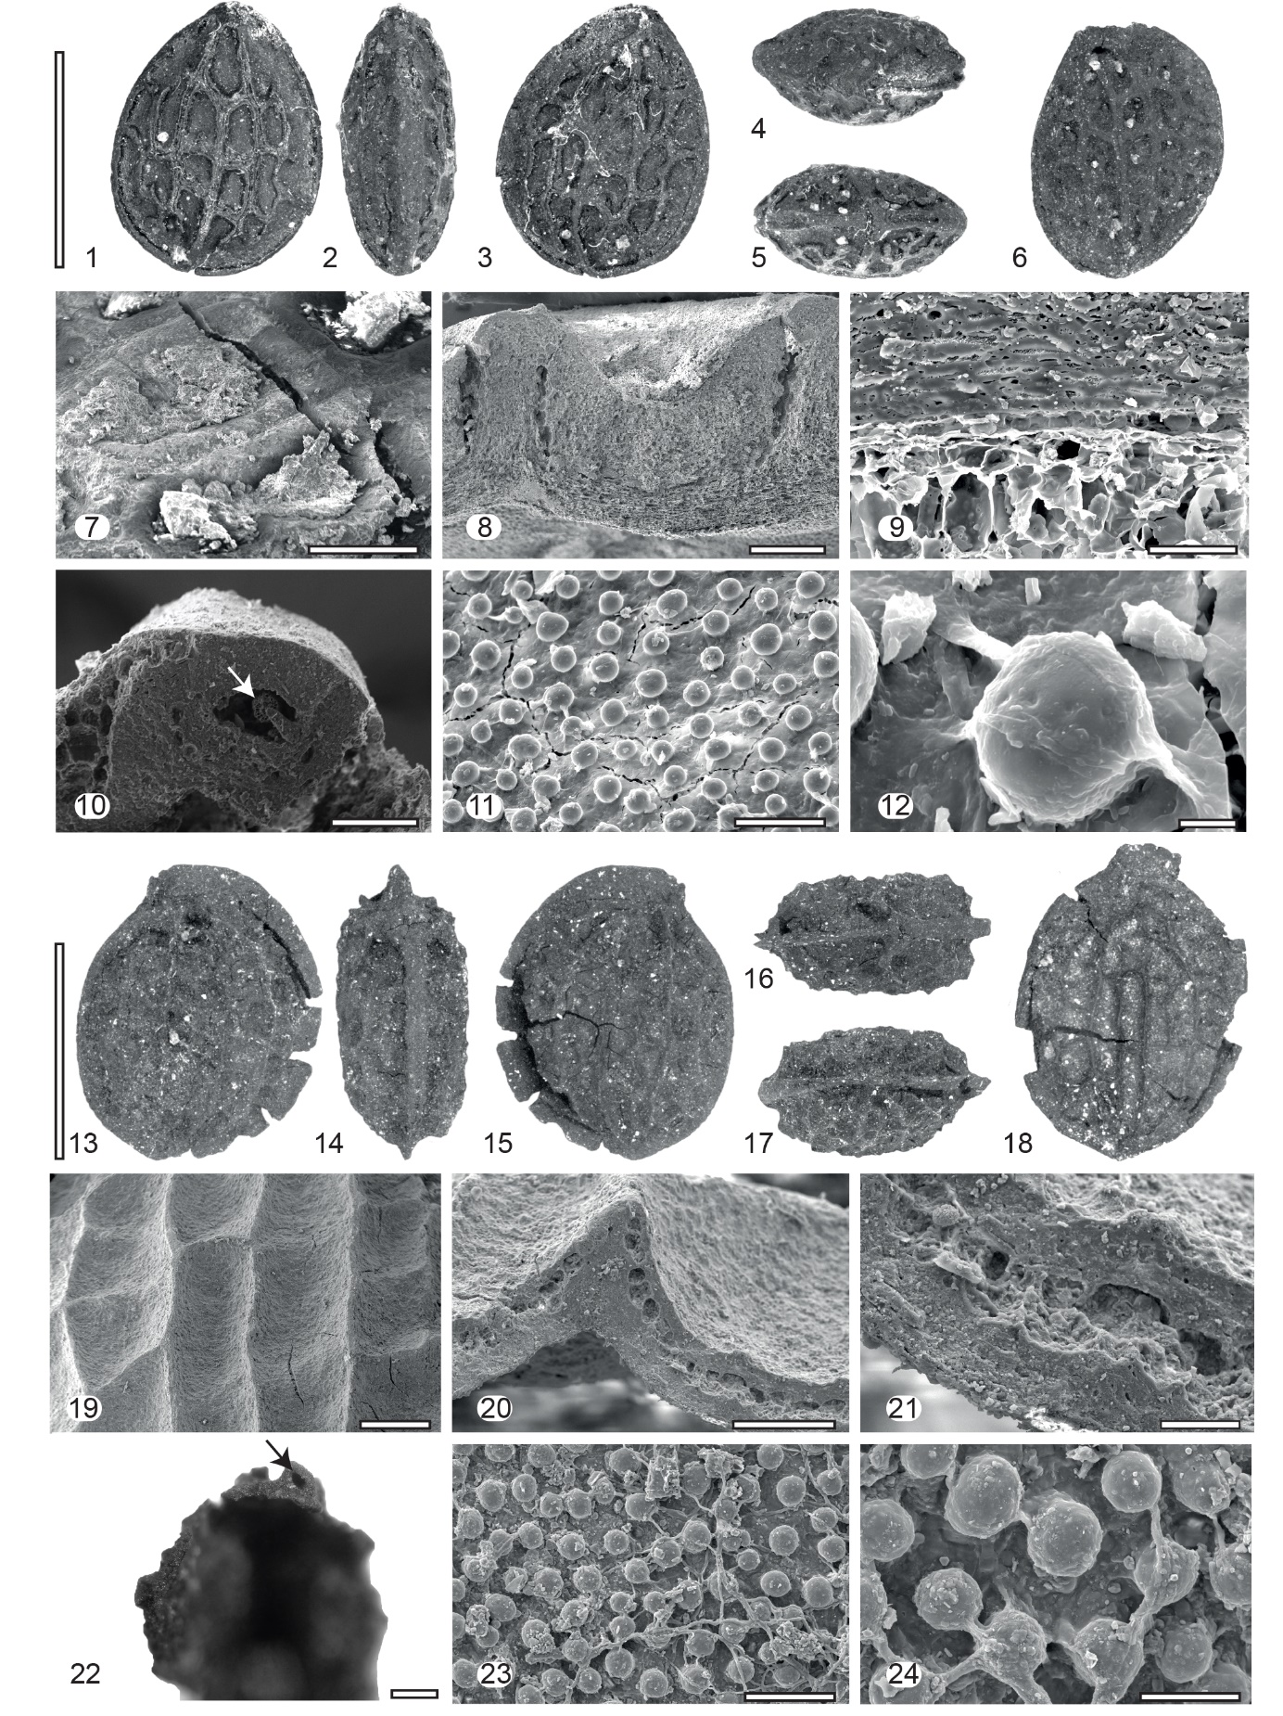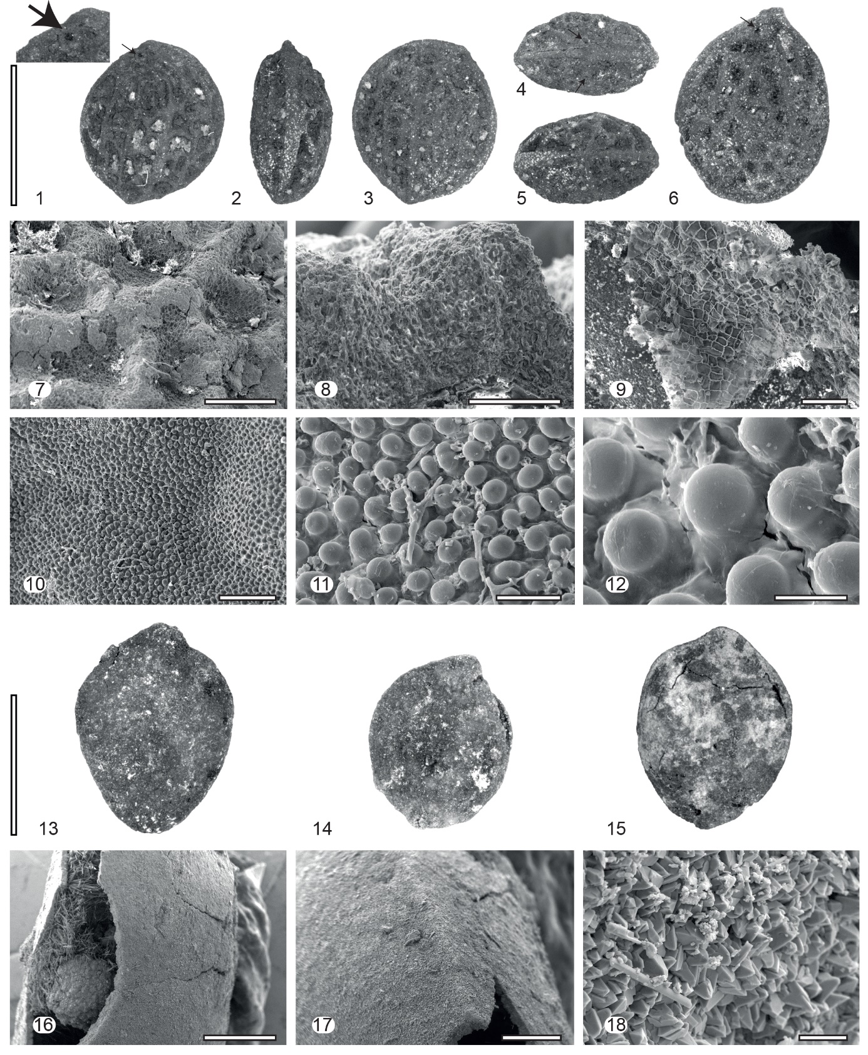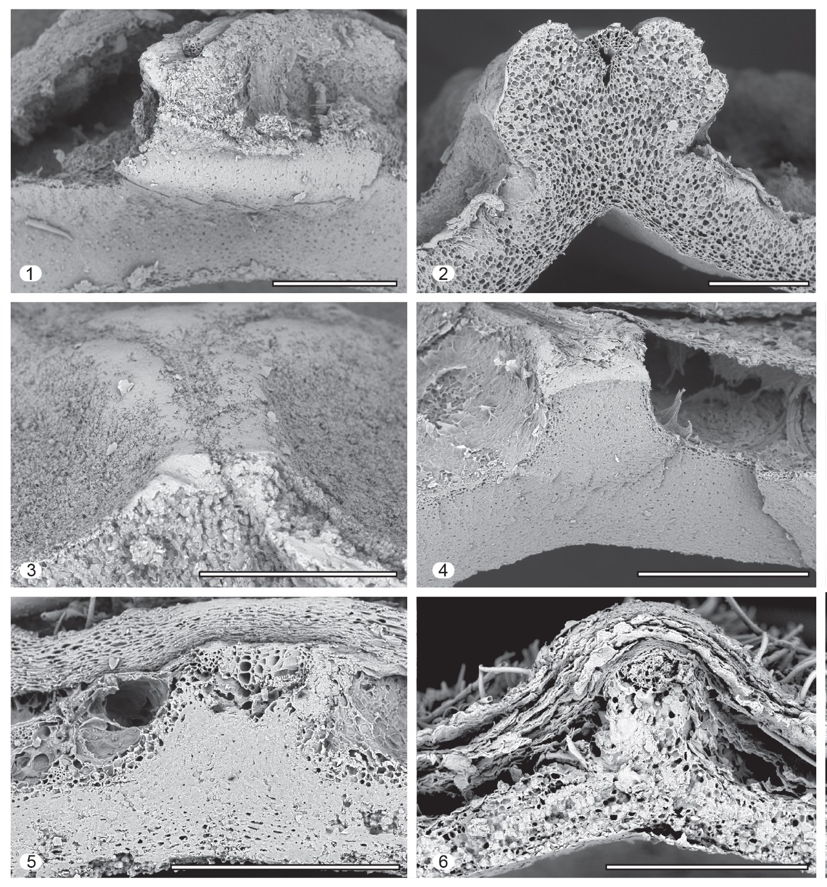

Table 1. Comparative table of features of fossil and modern endocarps of Iodes
Species | Endocarp length (mm) | Endocarp width (mm) | Endocarp thickness (mm) | Endocarp ornamentation | Endocarp ridging pattern | Apex vascular structure | Freely ending ridgelets |  | Number of areoles | Shape of ridges | Ridges at the point of the base | Ridges vertically | Thickness of endocarp wall (µm)
Croomiocarpon missippiensis Stull, Manchester & Moore | 20 | 18 | ? | Ridged | Reticulate | Absent (Bulge) |  | Rare or absent | 9–11 | Angular | 1 | 3 | 1140–1160
Hosiea pterojugata Mai | 4–6 | 4–5 | ? | Ridged | Reticulate | ? |  | Rare or absent | ? | ? | ? | ? | ?
Iodes acuta Del Rio & De Franceschi | 5.8–8.0 | 3.6–5.4 | ? | Ridged | Reticulate | Absent (Bulge) |  | Rare or absent | 10–25 | Sharp | 2 | 3 & 6 | 80–130
Iodes acutiform(is?) Chandler | 6 | 3.5–4 | ? | Ridged | Reticulate | Horns |  | Rare or absent | 15–15 | Sharp | ? | 4 & 3 | 200
Iodes africana Welw. ex Oliv. | 10.8–11.7 | 8.5–9.1 | 4.5 | Ridged | Reticulate | Absent |  | Present | 21–25 | Rounded | 6 | 3 | 154–171
Iodes balansae Gagnep. | 32.7 | 15.2 | ? | Ridged | Diffuse & Reticulate | Horns |  | Present | ? | Angular | 2 | 3 | 434–450
Iodes bilinica (Ettingshausen) Stull, Adams, Manchester et Collinson | 9–16 | 7–11 | 5–6 | Ridged | Reticulate | Pores |  | Present | ? | Sharp | 2 | 3 & 5 | 650–650
Iodes brownii (Berry) Stull, Adams, Manchester et Collinson | 7.5–9.5 | 5–7.5 | ? | Ridged | Reticulate | Horns |  | Rare or absent | 20–25 | Rounded (?) | 2 | 5 & 6 & 7 | 300–400
Iodes cirrhosa Turcz. | 12.6 | 9.5 | 4.5 | Ridged & Rugose | Diffuse |  |  | Not applicable | Not applicable | Rounded | 0 & 2 | 2 | 381–405
Iodes corniculata Reid & Chandler | 8–9 | 5.5–7.0 | 4 | Ridged | Reticulate | Horns |  | Not applicable | 15–20 | Rounded | 2 | 3 & 4 | ?
Iodes eocenica Reid et Chandler | 13.5–15 | 12.0 | 5–6 | Ridged | Reticulate | Horns |  | Rare or absent | ? | Rounded | 2 | 2 | ?
Iodes germanica Knobloch & Mai | 4–5 | 2.6–3.2 | ? | Ridged | Reticulate | Absent (?) |  | Rare or absent | 20 | ? | ? | 2 & 3 | ?
Iodes kamerunensis Engl. | 10.9 | 9 | 7.5 | Ridged | Reticulate | Absent |  | Present | 1–3 | Rounded | 2 | 1 | 154–181
Iodes klaineana Pierre | 12.1 | 7.6 | 6.3 | Ridged | Reticulate | Absent |  | Present | 13–15 | Rounded | 2 | 3 | 128–173
Iodes liberica Stapf | 10.4 | 7.1 | 7 | Ridged | Diffuse | Absent |  | Not applicable | Not applicable | Sharp | 2 | 1 | 138–172
Iodes madagascariensis Baill. | 7.6–8 | 4.6 | 4.3 | Ridged | Reticulate | Absent |  | Rare or absent | About 80 | Rounded | 4 | 2 & 3 | 165–201
Iodes multireticulata Reid et Chandler | 8–12.5 | 4–7.5 | 3.4 | Ridged | Reticulate | Absent |  | Rare or absent | 30–50 | Rounded | 2 | 4 & 5 | ?
Iodes occidentalis S.E. Allen, Stull & Manchester | 7.1 | 6.2 | ? | Ridged | Reticulate | Absent |  | Present | 26 | Rounded | 2 | 4 & 3 | 640
Iodes ovalis Blume | 17.8 | 11 | 8.6 | Ridged & Rugose | Reticulate | Horns |  | Present | 3–4 | Angular | 2 | 3 | 314–375
Iodes parva Del Rio, Thomas & De Franceschi | 4.4–6 | 3.5–5.2 | 2.6–3.5 | Ridged | Reticulate | Horns |  | Rare or absent | 11–20 | Rounded | 2 | 4 & 5 & 6 | 160–260
Iodes perrieri Sleumer | 11.5 | 10.9 | 9.2 | Ridged | Diffuse | Pores |  | Not applicable | Not applicable | Sharp | 4 | 2 | 317–338
Iodes philippinensis Merr. | 12.4 | 6–7.6 | 5–6.5 | Ridged | Diffuse | Horns |  | Not applicable | Not applicable | Rounded | 0 & 2 | 2 | 229–282
Iodes redii Del Rio, Thomas & De Franceschi F | 9.2–10.8 | 6.7–7.5 | 2.9–4.6 | Ridged | Reticulate | Horns |  | Rare or absent | 9–19 | Rounded | 4 | 4 & 5 | 250–270
Iodes rigida Del Rio & De Franceschi | 3.7–9.3 | 3.0–6.5 | ? | Ridged | Reticulate | Absent |  | Rare or absent | 0–20 | Angular | 2 | 5 | 260–500
Iodes rivecourtensis Del Rio, Thomas & De Franceschi | 8.2–12.0 | 6.3–9.9 | 2.8–5.9 | Ridged | Reticulate | Horns/Pores |  | Rare or absent | 8–22 | Rounded | 2 | 4 & 5 & 6 | 320–700
Iodes scandens (Becc.) Utteridge & Byng | 14.7 | 12.9 | 11.2 | Ridged | Reticulate | Horns |  | Present | 13–18 | Angular | 2 | 2 & 3 | 502–564
Iodes seguinii (H, Lév.) Rehder | 16.5 | 11.0 | 8.1 | Smooth | Not applicable | Absent |  | Not applicable | Not applicable | Not applicable | 0 | 0 | 173–226
Iodes seretii (De Wild.) Boutique | 11.6 | 8.7 | 5.9 | Ridged | Reticulate | Absent |  | Rare or absent | 23–25 | Rounded & Angular | 6 | 3 & 4 | 227–245
Iodes sinuosa Del Rio, Thomas & De Franceschi | 4.6–5.3 | 3.7 | 2.5 | Ridged | Reticulate | Horns |  | Rare or absent | 16–17 | Sharp | 2 | 3 & 4 | 220–240
Iodes tubulifera Del Rio, Thomas & De Franceschi | 10 | 6 | 2 | Ridged | Reticulate | Horns |  | Rare or absent | 21 | Sharp | 2 | 5 | 260
Iodes yatesii Merr. | 33.8 | 17 | 10.7 | Ridged | Reticulate | Pores |  | Present | 7–8 | Angular | 2 | 3 | 258–322
Palaeohosiea marchiaca (Mai) Kvaček & Bůžek | 6–10 | 4–7 | ? | Ridged | Reticulate | Horns (?) |  | Rare or absent | ? | ? | ? | ? | ?
Palaeohosiea suleticensis Kvaček & Bůžek | 15–20 | 13–16 | ? | Ridged | Reticulate | Absent (?) |  | Rare or absent | ? | ? | 1(?) | 2 & 3 | ?

Species | Thickness of endocarp wall with ridges (µm) |  | Diameter of papillae (µm) |  | Density of papillae (µm) |  | Cell composition of endocarp wall |  | Orientation of endocarp wall cells | Geological period |  | Geographical sampling |  | References
Croomiocarpon missippiensis Stull, Manchester & Moore | 2200-2500 | ?–? |  | ?–? |  | ? |  | ? |  |  | Eocene |  | North America |  | Stull et al., 2011
Hosiea pterojugata Mai | ? | ? |  | ? |  | ? |  | ? |  |  | Paleocene |  | Europe |  | Mai, 1987
Iodes acuta Del Rio & De Franceschi | 180–390 | 10–18 |  | 230–410 |  | Divided into distinctive layers |  | Isodiametric & Periclinal |  |  | Eocene |  | Europe |  | This study
Iodes acutiform(is?) Chandler | ? | ? |  | 900–1600 |  | ? |  | ? |  |  | Eocene |  | Europe |  | Chandler, 1962
Iodes africana Welw. ex Oliv. | 268–277 | 14.3–17.4 |  | 810–840 |  | Divided into distinctive layers |  | Periclinal & Isodiametric |  |  | Extant |  | Africa |  | This study
Iodes balansae Gagnep. | 543–1311 | 20 |  | ? |  | Divided into distinctive layers |  | Periclinal & Isodiametric |  |  | Extant |  | Asia |  | This study
Iodes bilinica (Ettingshausen) Stull, Adams, Manchester et Collinson | 1000 | ? |  | ? |  | ? |  | ? |  |  | Eocene |  | Europe |  | Chandler, 1925, Kvaček and Bůžek, 1995, Collinson, 2012
Iodes brownii (Berry) Stull, Adams, Manchester et Collinson | ? | 30 |  | ? |  | ? |  | ? |  |  | Eocene |  | North America |  | Allen et al., 2015, Stull et al., 2016
Iodes cirrhosa Turcz. | 813–1064 | 8.6–15.3 |  | 462 |  | Divided into distinctive layers |  | Isodiametric & Periclinal |  |  | Extant |  | Asia |  | This study
Iodes corniculata Reid & Chandler | ? | ? |  | ? |  | ? |  | ? |  |  | Eocene |  | Europe |  | Reid and Chandler, 1933
Iodes eocenica Reid et Chandler | ? | 16 |  | ? |  | ? |  | ? |  |  | Eocene |  | Europe |  | Reid and Chandler, 1933
Iodes germanica Knobloch & Mai | ? | ? |  | ? |  | ? |  | ? |  |  | Cretaceous |  | Europe |  | Knobloch and Mai, 1986, Mai, 1987
Iodes kamerunensis Engl. | 460–470 | ? |  | ? |  | Homogeneous |  | Isodiametric |  |  | Extant |  | Africa |  | This study
Iodes klaineana Pierre | 300–360 | ? |  | ? |  | Divided into distinctive layers |  | Isodiametric & Periclinal |  |  | Extant |  | Africa |  | This study
Iodes liberica Stapf | 257–266 | ? |  | ? |  | Divided into distinctive layers |  | Isodiametric & Periclinal |  |  | Extant |  | Africa |  | This study
Iodes madagascariensis Baill. | 227–265 | 13.3 |  | ? |  | Divided into distinctive layers |  | Periclinal & Isodiametric |  |  | Extant |  | Madagascar |  | This study
Iodes multireticulata Reid et Chandler | ? | 50 |  | ? |  | ? |  | ? |  |  | Eocene |  | Europe |  | Reid and Chandler, 1933
Iodes occidentalis S.E. Allen, Stull & Manchester | ? | 30–50 |  | 99–180 |  | ? |  | ? |  |  | Eocene |  | North America |  | Allen et al., 2015
Iodes ovalis Blume | 490 | 9.2–11.8 |  | ? |  | Divided into distinctive layers |  | Isodiametric & Periclinal |  |  | Extant |  | Asia |  | This study
Iodes parva Del Rio, Thomas & De Franceschi | 400–560 | 10–14 |  | 510–1060 |  | Divided into distinctive layers |  | Isodiametric & Periclinal |  |  | Paleocene & Eocene |  | Europe |  | Del Rio et al., accepted
Iodes perrieri Sleumer | 340–426 | 12.3–18 |  | 448 |  | Divided into distinctive layers |  | Isodiametric & Periclinal |  |  | Extant |  | Madagascar |  | This study
Iodes philippinensis Merr. | 360–387 | ? |  | ? |  | Divided into distinctive layers |  | Isodiametric & Periclinal |  |  | Extant |  | Asia |  | This study
Iodes redii Del Rio, Thomas & De Franceschi F | 800 | ? |  | ? |  | Divided into distinctive layers |  | Isodiametric & Periclinal |  |  | Paleocene |  | Europe |  | Del Rio et al., accepted
Iodes rigida Del Rio & De Franceschi | 430–580 | 10–26 |  | 290–570 |  | Divided into distinctive layers |  | Isodiametric & Periclinal |  |  | Eocene |  | Europe |  | This study
Iodes rivecourtensis Del Rio, Thomas & De Franceschi | 380–1590 | 13–17 |  | 126–260 |  | Divided into distinctive layers |  | Isodiametric & Periclinal |  |  | Paleocene |  | Europe |  | Del Rio et al., accepted
Iodes scandens (Becc.) Utteridge & Byng | 652–672 | ? |  | ? |  | Divided into distinctive layers |  | Periclinal &Anticlinal |  |  | Extant |  | Asia |  | No voucher (MO).
Iodes seguinii (H, Lév.) Rehder | ? | ? |  | ? |  | Homogeneous |  | Periclinal |  |  | Extant |  | Asia |  | This study
Iodes seretii (De Wild.) Boutique | 320–386 | 11.8–13.7 |  | ? |  | Divided into distinctive layers |  | Isodiametric & Periclinal |  |  | Extant |  | Africa |  | BR0000015596772
Iodes sinuosa Del Rio, Thomas & De Franceschi | 350–390 | 11–15 |  | 600 |  | Divided into distinctive layers |  | Isodiametric & Periclinal |  |  | Paleocene |  | Europe |  | Del Rio et al., accepted
Iodes tubulifera Del Rio, Thomas & De Franceschi | 380 | 16–19 |  | 270 |  | Divided into distinctive layers |  | Isodiametric & Periclinal |  |  | Paleocene |  | Europe |  | Del Rio et al., accepted
Iodes yatesii Merr. | 430–959 | ? |  | ? |  | Divided into distinctive layers |  | Isodiametric & Periclinal |  |  | Extant |  | Asia |  | This study
Palaeohosiea marchiaca (Mai) Kvaček & Bůžek | ? | 16–25 |  | ? |  | ? |  | ? |  |  | Paleocene |  | Europe |  | Kvaček and Bůžek, 1995
Palaeohosiea suleticensis Kvaček & Bůžek | ? | 15–20 |  | ? |  | ? |  | ? |  |  | Oligocene |  | Europe |  | Kvaček and Bůžek, 1995

