SUPPORTING INFORMATION
Biotinylated magnetic molecularly imprinted polymer nanoparticles for cancer cell targeting and controlled drug delivery
Maria Nerantzaki, * Aude Michel, Laurence Petit,^{c} Maylis Garnier, Christine Ménager and Nébéwia Griffete *

Maria Nerantzaki
Institut Charles Sadron UPR22
University of Strasbourg, CNRS
Strasbourg Cedex 2, 67034, rance
Email: maria.nerantzaki.@unistra.fr

A. Michel, M. Garnier, C. Ménager and N. Griffete
Physicochemistry Laboratory of Electrolytes and Interfacial Nanosystems (PHENIX)
Sorbonne University, UPMC, CNRS : UMR8234
Paris Cedex 05, 75252, France
E-mail : nebewia.griffete@sorbonne-universite.fr

Laurence Petit
Institute of Biology Paris Seine (IBPS)
Sorbonne University, UPMC, CNRS : UMR7622
7-9 quai. Saint Bernard Paris, 75005, France

EXPERIMENTAL SECTION
- Materials
2-(dodecylthiocarbonothioylthio)-2-methylpropionic acid (TTMA), methacrylic acid (MA), ethylene glycol dimethacrylate (EGDMA), doxorubicin hydrochloride (DOX) and acryloxyethyl thiocarbamoyl rhodamine B (RhB), were purchased from Sigma Aldrich. N,N-Dimethylformamide (DMF), methanol (MEOH) and ethanol (EtOH) were also supplied from Sigma Aldrich. Azo(bis)isobutyronitrile (AIBN), was provided by Fluka. Ethyldiisopropylamine (DIPEA), 1,4-Dioxane and N,N,N′,N′-Tetramethyl-O-(N-succinimidyl)uronium tetrafluoroborate (TSTU) were supplied by Merck. Biotin-PEG2-NH2 was supplied from Sigma Aldrich. All chemical reagents were of analytical and were used as received without any purification. Water was distilled and deionized
- Experimental
- Grafting of iniferter (TTMA) agent on γ-Fe₂O₃
To stabilize and functionalize the surface of γ-Fe₂O₃ NPs, TTMA functions were anchored at the nanoparticle surface by complexation with iron ions, following a previously published protocol, with slight modifications (Scheme 1). First, bare γ-Fe₂O₃ NPs were synthesized by a coprecipitation method according to literature data, followed by a size sorting process through salt destabilization as reported by S. Lefebure et al.¹, to get the largest NPs, most efficient for magnetic hyperthermia. TEM analysis showed particles with an average particle diameter (d₀) of 11 nm and a polydispersity (σ) of 0.23. After this procedure, 10 mL of the suspension ([Fe] = 1 M) was added to 60 mL of MEOH under ultrasonication, followed by the addition of 0.05 g of TTMA. The mixture was shaken overnight at a rate of 300 rpm. The final product (labeled as Fe₂O₃@TTMA) was separated and purified by magnetic collection, washed threefold with MEOH and dried in an oven at 35 °C.
- Graft polymerization of the fluorescent PMA-co-RhB DOX imprinted MIP on the surface of functionalized γ-Fe₂O₃ labelled MIP@DOX MNPs
In a round-bottom flask, 100 mg of functionalized γ-Fe₂O₃ NPs were dispersed in 250 mL of EtOH. Next, 0.6 mmol of MA, 0.009 mmol of acryloxyethyl thiocarbamoyl rhodamine B (1.5 mol % relative to MA), 0.05 mmol of DOX as a template, 2.4 mmol of EGDMA and 0.18 mmol of AIBN as cross-linker were added to the dispersion. The resulting mixture was bubbled with N₂ gas for 10 min, the flask was sealed, and kept in an oil bath at 60 °C for 24h. Materials synthesized were separated and purified by magnetic collection, washed using EtOH for reagent excess removal. The excess of DOX was quantified in the supernatants to determine the final concentration of DOX per gram of particles (12µM of DOX per gram of particles) or per iron concentration (25µM of DOX for an iron concentration of 10mM).

- TSTU-mediated surface biotinylation of MIP@DOX MNPs
Carbodiimides are commonly used as activators for the synthesis of biotin targeted polymeric nanoparticles.Despite the fact that they still hold their place, recently, a new family of coupling reagents became popular, the uronium salt-based class such TSTU.18 In contrast to activation by carbodiimides, these compounds achieve high coupling rates accompanied by few undesired side reactions, but require the presence of a base like diisopropylethylamine (DIPEA) or Hünig's base. For conjugating Biotin-PEG₂-NH₂ linker to MIP@DOX MNPs surface, first, 250 mg of MIP@DOX MNPs were dissolved under ultrasonication (5 nm) in a mixture of DMF (7.5 ml), dioxane (17.5 ml) and water (7.5 ml). Subsequently, Biotin-PEG₂-NH₂ (26 mg), DIPEΑ (27 μL), TSTU (20 mg) were added to the reaction mixture under stirring. After 30 mn of magnetic stirring, the resulting biotinylated magnetic nanoparticle suspension was separated and purified by magnetic collection and washed threefold with ultrapure milli-Q water. The resulting biotinylated magnetic nanoparticles (MIP@DOX-BT MNPs) were then dried in an oven at 30°C and stored in a vacuum desiccator.
- Instrumentation
Transmission Electron Microscopy (TEM) and High resolution Transmission Electron Microscopy (HRTEM). The size distribution parameters (diameter d, polydispersity σ) of MNPs, MIP@DOX and MIP@DOX-BT were characterized using a JEOL-100 CX transmission electron microscope. A droplet of the aqueous diluted nanomaterial dispersion was deposited on a carbon-coated copper grid and dried at room temperature for at least 5 h before TEM observations. For the visualization of the polymer on the nanoparticles, a negative staining was performed by exposing the grids to a drop of a 1 wt% ammonium molybdate solution in water for 1 min. The grids were tapped dry with a piece of ﬁlter paper to remove the excess stain and air-dried before TEM measurements.
Fourier Transform Infra-Red (FT-IR). Infrared spectra were obtained on a Bruker Tensor 27 spectrometer on pressed KBr pellets. Spectra were obtained at regular time intervals in the MIR Region of 4000 – 400 cm^{–1} at a resolution of 4 cm^{–1} and analyzed using OPUS software.
Thermogravimetric Analysis (TGA). The weight loss of the materials was determined by thermogravimetric analysis using a TGA SDT Q600, TA Instruments, using an aluminum melting pot. The samples were analyzed under nitrogen with a flow rate of 100 mL of N₂(g)·min⁻¹ and at a heating rate of 10 °C·min⁻¹ from room temperature (25 °C) to 800 °C.
Dynamic light scattering (DLS). Hydrodynamic diameter (dh) measurements were recorded using a
Malvern Instruments Nanosizer.

Ultraviolet-visible spectrophotometry (UV-vis). Absorbance measurements were done with an Avantes UV-visible spectrophotometer, with 100 µm optical fibers. UV/VIS measurements were configured with a range from 200 to 1100 nm. A combined deuterium-halogen light source was used.

- Avidin/Hydroxyazobenzene-2-carboxylic acid (HABA) assay
The avidin/HABA assay was performed as reported by Green², using a standard HABA Biotin-detection agent (Uptima Interchim, Montlucan, France). Briefly, the avidin/HABA reagent was prepared according to the manufacturer’s instructions by adding 10 mg of avidin and 600 μL of HABA solution (24.2 mg in 9.9 mL of water and 0.1 mL of 1N NaOH) to 20 mL phosphate buffered saline (PBS pH 7.1). Afterwards, using an Avantes UV−visible spectrophotometer (100 μm optical fiber, deuterium halogen light source) with wavelengths from 200 to 800 nm, we confirmed that the optical density at 500 nm (OD500) of the resulting avidin/HABA “stock” solution was 1. Then, the stock solution was further diluted by mixing 2.5 mL of it with 2.5 mL of PBS and OD500 was measured. Next, 5mg of sample (either MIP@DOX or MIP@DOX-BT) were added to a 3 mL of the diluted avidin/HABA solution (250 ppm). Interaction of biotin with avidin requires about 60 min, so the samples were incubated at room temperature for 1 h under shaking. After incubation, the nanoparticles were centrifuged at 10000 rpm for 5 min followed by magnetic separation and OD500 was measured from the supernatant. Based on Beer-Lambert law (Figure SI5), the biotin concentration (nanomoles of biotin per milliliter of sample solution) was calculated using the following equation (∆A₅₀₀/34)×1000, where ΔA₅₀₀ should be taken as the change in OD500 (34 = mM extinction coefficient at 500 nm).³ The final biotin-binding capacity of each sample was calculated based on the biotin concentration (nmol ml⁻¹), the amount of sample taken (5 mg) and the final volume (3 ml).
- In vitro DOX release experiments
In vitro doxorubicin release studies of MIP@DOX-BT MNPs in PBS (2mL, [Fe]=5mM) were monitored in various conditions: at human body temperature (37°C) and under an alternative magnetic field (six AMF pulses of 5 minutes with a 30s interval, 335 kHz, 9mT) at 37°C. At each time point the supernatant was collected by magnetic separation and UV/Vis spectroscopy was used to confirm the successful cleavage of the molecule from the MIP and to quantify the amount of molecule released. After the analysis, the supernatant was replaced in the initial eppendorf containing the MIP@DOX-BT MNPs nanoparticles at 37°C for the next measure.

- Cell experiments
Human breast adenocarcinoma (MCF7) cell lines were cultured in DMEM supplemented with 10% FBS, 1% Glutamine and 0,5% penicillin/streptomycin in a humidified atmosphere containing 5% CO₂ at 37 °C.
Flow cytometry
MCF7 cells were seeded in well plates (200 000 cells/well in 200 µL DMEM containing 10% FBS, µ-Slide 12 Well ibiTreat). Cells were incubated at 37 °C in a 5% CO₂ atmosphere for 24 h before the medium was removed, and new medium containing the specified nanoparticles ([Fe] = 5 mM in 500 µL of complete cell culture medium) was added. Then, wells were kept incubated for one hour at 37°C in 5% CO₂ or at 4°C. After incubation, the cells were washed with PBS three times to remove the particles that were not internalized. 100 µL of trypsin/EDTA was applied in each well to enable cell detachment, 400µL of complete cell culture medium were added to neutralize the trypsin/EDTA action. Then the cells were centrifuged five minutes at 1000rpm, supernatants were removed and the cells were washed with 1ml of PBS/SVF (1%) and were centrifuged again. Finally, the cells were taken back in 150µL of PBS and the vials were kept in ice. Two untreated wells were kept as control. Cells were analyzed on a MACSQuant VYB (Miltenyi Biotec) flow cytometer after addition of 1.5µL DAPI (40µg/mL) to eliminate dead cells. Datas were reanalyzed using FlowJo10.8 software.
Hyperthermia experiments. Hyperthermia experiments for nanoparticles in suspension were conducted on a magneTherm apparatus (magneTherm AC system, Nanotherics Corp., Newcastle under Lyme, UK) at 335kHz and 9 mT. The temperature was probed using a fluorooptic fiber thermometer. The experiment is the same than the above described one except that we only used the cells incubated with the particles at 37°C and they are not analysed using flow cytometry but the vials are introduced in the magneTherm apparatus.
Confocal Imaging. The internalization of magnetic nanomaterials inside MCF-7 cancer cells was analyzed by confocal microscopy. The living cells were observed with an Olympus JX81/BX61 device/Yokogawa CSU device spinning disk microscope (Andor Technology plc, Belfast, Northern Ireland), equipped with a 60× Plan-Apon oil objective lens. The rhodamine B was excited with a laser at 561 nm, and fluorescence emission was collected in the red channel at 604 nm. As DOX has a λ_{Em}= 595 nm, it is possible that the observed fluorescence come both from DOX and RHO. However, as they are internalized in the particles, before AMF application, the red fluorescence observed here is linked to the presence of MIP@DOX-BT MNPs. We could distinguish the two fluorescence if DOX is excited with laser at 488 nm, and fluorescence emission collected in the green channel at 561 nm.

SUPPLEMENTARY FIGURES
Fig. SI1 Principle of surface modification of the magnetic MIP using TSTU.

Fig. SI2 FTIR spectra of a) Fe₂O₃ and Fe₂O₃@TTMA and b) Fe₂O_{3,} Fe₂O₃@TTMA, MIP@DOX and MIP@DOX-BT MNPs.

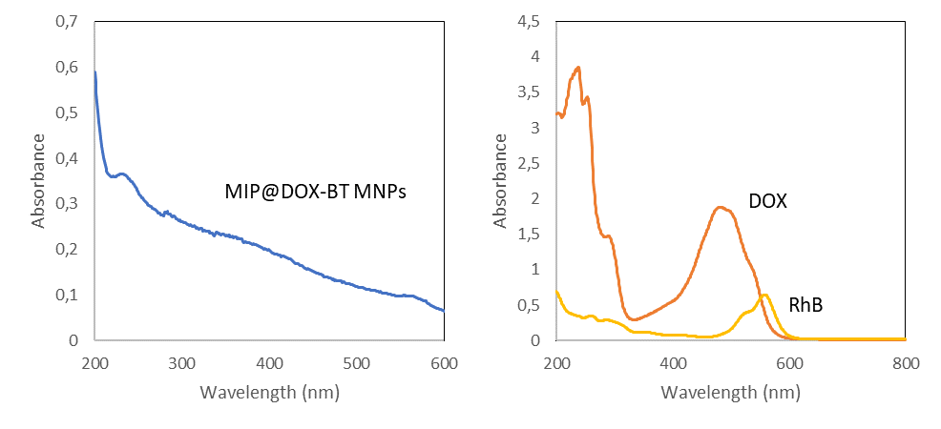
Fig. SI3 UV-vis spectra of MIP@DOX-BT (0.4 g of particles), DOX (0.1mg/mL) and acryloxyethyl thiocarbamoyl rhodamine B (RhB – 1mg/mL).

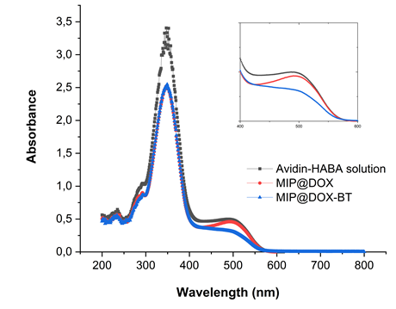
Fig. SI4 UV-vis spectra of the avidin/HABA complex and the avidin-HABA complex added with MIP@DOX and MIP@DOX-BT, respectively, in 50 mM PBS buffer, 50 mM NaCl, pH 7.1. The zoomed region at 500 nm is shown in the subset.
Fig. SI5 Calibration curve according to Beer-Lambert equation for avidin/HABA complex by UV-visible spectroscopy. HABA and avidin bind strongly to produce an orange colored complex that absorbs light at 500 nm.
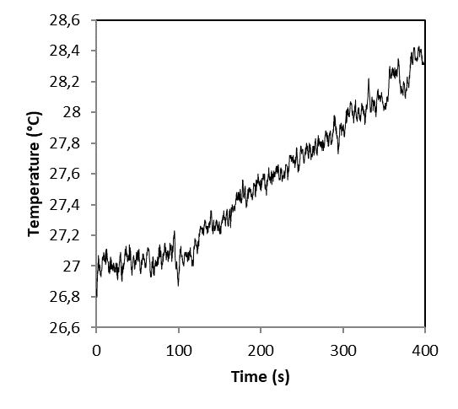
Fig. SI6 Temperature variation of in PBS (2 mL, [Fe]=1 mM)) after 5 min excitation at 335 kHz, 9 mT. The temperature of the magneTherm measurement cell was 40°C after the AMF exposure.
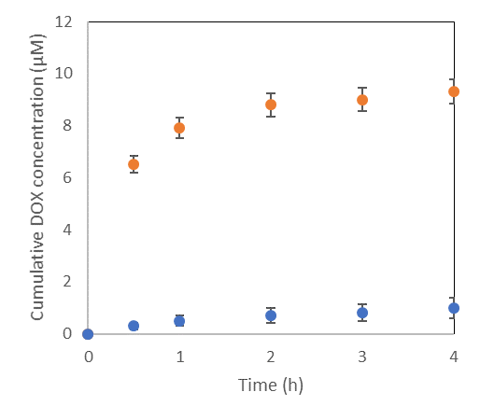
(a)
(b)
Figure SI7. Cumulative DOX release in µmol/L of MIP@DOX-BT MNPs ([Fe]=5 mM) (a) at 37°C without magnetic field and (b) under AMF (335 kHz, 9mT).

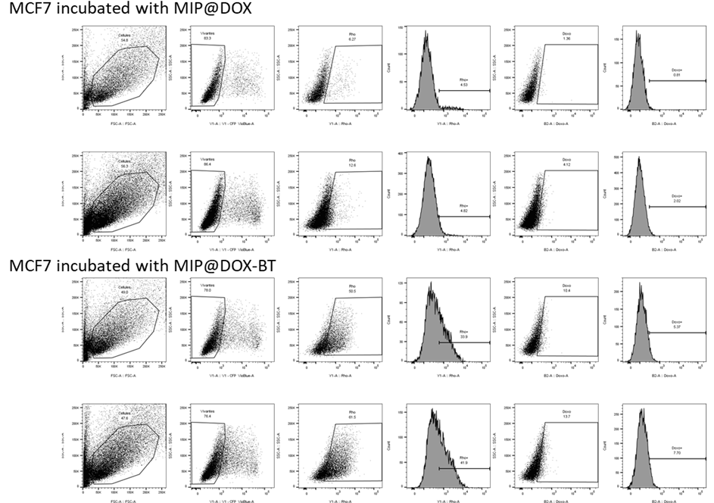
Figure SI8. Doxorubicin and Rhodamine fluorescent intensity of MCF-7 obtained by flow cytometry incubated at 4 or 37°C with MIP@DOX and MIP@DOX-BT.

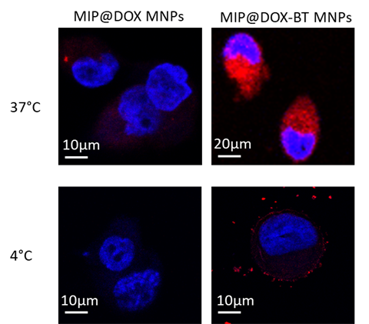
Fig. SI9 Confocal microscopy images of MCF-7 after incubation with MIP@DOX and MIP@DOX-BT at 37° and 4°C. the nucleus is coloured with DAPI (in blue on the images) and the particles appear red due to the rhodamine B and DOX fluorescence.

Figure SI10. Temperature increase (from 37.3 to 38.2°C) during AMF exposure with cells, corresponding to athermal conditions.

References
1. S. Lefebure, E. Dubois, V. Cabuil, S. Neveu and R. Massart, Journal of Materials Research, 1998, 13, 2975-2981.
2. N. M. Green, Biochem J, 1965, 94, 23c-24c.
3. K. Qi, Q. Ma, E. E. Remsen, C. G. Clark and K. L. Wooley, Journal of the American Chemical Society, 2004, 126, 6599-6607.

